

Final Project for

GDSD

Class

SoSe

2022

ProClick

–

Online

Media Point

2022

**Team Members**

**Team Member Name Role**

|  |  |
| --- | --- |
| **Ahmad Hassan** | Team Lead + Software Developer |
| **Bilal Ahmad** | Software Developer |
| **Tarmah Bin iqbal** | Software Developer front end lead |
| **Mayank Chetan Parvatia** | **Software Developer** |
| **Abdullah Khalid** | **GitHub Master + Software Developer** |
| **Hamza Mazher** | **BackEnd Lead** |

**URL**

<https://proclick2022.azurewebsites.net/>

Contents

Milestone 1 1

1.1. Executive Summary 1

1.2 Personae and main Use Cases 1

1.3 List of Main Data Items and Entities 3

1.4 Functional Requirements 3

1.5 Non-functional Requirements 5

1.7 High-level system architecture and technologies used 6

1.8 Teams and Roles 7

1.9 Checklist 7

Milestone 2 8

2.1 Functional Requirements (Prioritized) 8

2.2 List of Main Data Items and Entities 9

2.3. UI Mockups and Storyboards 10

2.4 High Level Architecture, Database Organization 20

2.5.High-levelUML Diagrams 21

2.5.1. UML Class Diagram 21

2.5.2 Component Diagram 22

2.5.2 use Case 23

2.6 Identify actual key risks for your project at this time 24

2.7 Project Management 24

Milestone 3 24

3.1List of tasks the team chose to focus on 25

3.2 List of final Product P1 functions agreed at the meeting 25

Milestone 4 26

4.1 Product Summary 26

4.2 Major Committed Functions 26

4.3 Usability Test Plan 27

4.4 QA Test Plan 32

4.5 Product screenshots 34

4.6 Code Review…………………………………………………………………………………………………..41

4.6 Self-check on best practices for security…………………………………………………………………...50

4.7 Self-check: Adherence to original Non-functional specs………….……………………………………....51

0

# Milestone 1

## 1.1. Executive Summary

With the dawn of the Internet and the rapid expansion of the digital space over the past few decades, information accessibility across all sectors has skyrocketed. Consequently, the internet now serves as a distributed intermediary between service providers and consumers. Copyright and privacy issues have also scaled up due to large amount of digital data present on internet. Providing a web-based platform that leverages the internet's potential to simplify search, interaction and service provisioning between buyer and sellers opens unprecedented possibilities for both the parties. Providing platform to both buyer and seller for digital media will let them deal together at one platform, letting them share their digital products.

Our Project is a web-based application that allow user to sign in and either buy a digital product or sell it. User can see the product price, its quality and other features associated with it. He/she can see the availability of product also. User can also see who owns the product and history of product from its origin until now, who buys it who sells. Buyer and seller names will be given only against specific time interval. This is done to make user realize that product has regular buyer and sellers and buying of this product will give him advantage later. Reviews of specific product owner will be shown with product, so buyer can have some perception about product before buying. User can also rate specific product owner and product.

**Unique Selling Point**: If a user has uploaded 5 tutorials through their account, an access will be given to them and they can see one video of 1 hour for free.

We are a student team of curious software developers from Fulda, passionate to craft creative web- based solutions in order to simplify the exchange of information across digital space.

## 1.2 Personae and main Use Cases

**Personae and main Use Cases:**

A persona(s) is a profile that is going to represent the primary users. With the help of Personas, it will help in a fictional representation and generalization of a cluster of the target users who exhibit similar attitudes, goals, and behaviors in relation to the product. This will help the product in:

1. Navigate design and feature decisions.
2. Settle disputes with the personas in mind.

The 2 main personas are as follows:

1. Users

Students & Faculties

1. Admin

**a. Users:**

* + 1. **General overview:** Users can be anyone and from any department who are studying or working as a professor (E.g PA for faculties) in the Hochschule.
    2. **Goals:** The user’s goal is to use the web application for successfully uploading, downloading, buying, selling, and sharing media and graphics.
    3. **Skills:** The users know how to use SmartPhones, Desktops/Laptops, and have basic knowledge about how to use a website.
    4. **Pain points:** The users should always have an internet connection or a wifi connection in order to use the website. They must always be logged in in order to surf the website. They cannot upload media without the administrator’s approval.

**b. Admin:**

* + 1. **General overview:** The admin must be someone who is part of the project and have the credentials for keeping the website up and running.
    2. **Goals:** The Admin’s goal is to approve the user’s uploading content and maintain the website.
    3. **Skills:** The admin has knowledge about the system, and about the dashboard from where he/she can update, delete, and import users or the media content. iv. **Pain points:** The admin should always have an internet connection or a wifi connection in order to use the website. They must always be logged in in order to surf the webs.

**Use Cases:**

* 1. **Search Media:** When the users are interested in a particular media or file they should be searching for the desired media/ graphics in the search box field.

A user needs to find a media which is related to the Computer Science course, he/she will be able ist of items upon clicking on the search button. The user can also search items using the keywords like Mathematics Linear Algebra.

* 1. **Upload a media:** The users can directly upload a file media or graphics which will be first reviewed by the administrator.

The users will have the option to upload different types of media or files for example: For an image or a video, a camera icon will be displayed. The users can make a post that includes a normal text. Users can advertise products for sale or for free, just some type of message to the audience just by posting a message for example: Hello, I will be selling media(s) which is related to my latest research work in Artificial Intelligence on 30/06/2022. So grab the opportunity!

* 1. **Approve a media:** A media will be approved by the admin before it can go live on the website.

## 1.3 List of Main Data Items and Entities

The admin will check what the media is about, its type, and if it doesn’t contain any sort of sensitive or inappropriate content.

If a video contains any graphical content which is disturbing or supposed a hate speech, the admin will directly reject the media and put the user on the black list.

1. **Download a media:** After agreeing to the terms, one can download or access the item in full quality in some way. Free material should be downloadable in full quality right away, whereas selling media should only be obtained in full resolution after contacting the seller/owner. Both free media and purchased media can be downloaded anytime from the website.
2. **Delete a media:** If the owner/seller wishes to remove their content from their side, the media/material can be deleted at any moment and it will still be visible to the users as the media is stored on the server. Furthermore, the administrator has complete control over the removal of any content that is not legitimate to the users and may contain improper content, as well as the deletion of users.

In the event of deletion of the media from one’s device or device format, the user can still download the media from the website. Users who have already paid can download it at any time in the future. Only one copy will be there on the server. It will be safe on the server in the event that the user’s electronic gadget fails.

1. **Chat Message:** Users will be able to message the proprietors for further information about the material or anything else, and the message receiver will be able to respond in the chatbox. If there are any questions that need to be answered by the owner or the person who posted a certain media, the administrator can send messages to the users.

|  |  |  |  |
| --- | --- | --- | --- |
| **Sr. No** | **Entities** | **Data Items** | **Detail** |
| 1 | Admin | String | A system administrator is responsible for managing seller's profiles, as well as to approval of media. |
| 2 | Seller | String | This entity contains the seller’s information. |
| 3 | Reviews | String | When a buyer makes a purchase, there is a rating option to rate the seller’s content. |
| 4 | Chat | String | This feature connects the seller and the customer, allowing them to communicate with no trouble. |
| 5 | Buyer | String | It contains the buyer’s profile information |
| 7 | Media | String | This application’s most important feature is its media. So, in this entity, we’ll store media URLs of each product that will be linked with a specific buyer. |

## 1.4 Functional Requirements

|  |  |
| --- | --- |
| **Sr. no.** | **Functional Requirements** |
| 1. | User can sign up and log in to the system using the university email |
| 2. | User can search for the media. |
| 3. | User can upload media in the form of text, image, audio, or video. |
| 4. | User can download the media from the application |
| 5. | User can delete the media from the application which is uploaded by himself |
| 6 | User can access media owned by him anytime e.g if it gets deleted from computer |
| 7. | User can send messages to other users (sellers/buyers) to sell/buy media. |
| 8. | Admin user can view the media in the system |
| 9. | Admin can create new media in the system |
| 10. | Admin can delete media uploaded by the users |
| 11 | Admin can block certain users. |
| 12. | Admin user can approve the media uploaded by other users. |
| 13. | Admin can view the list of users registered in the system |
| 14. | Admin can update a user’s profile |
| 15. | User can see the number of total views on the media they uploaded |
| 16. | User can get recommended results based on his previous search or tags |

## 1.5 Non-functional Requirements

1. Application shall be developed, tested and deployed using tools and servers approved by Class CTO and as agreed in Milestone 0. Application delivery shall be from chosen cloud server

1. Application shall be optimized for standard desktop/laptop browsers e.g. must render correctly on the two latest versions of two major browsers

1. All or selected application functions must render well on mobile devices

1. Data shall be stored in the database on the team’s deployment cloud server.

1. No more than 50 concurrent users shall be accessing the application at any time

1. Privacy of users shall be protected and all privacy policies will be appropriately communicated to the users.

1. The language used shall be English (no localization needed)

1. Application shall be very easy to use and intuitive

1. Application should follow established architecture patterns

1. Application code and its repository shall be easy to inspect and maintain

1. No e-mail clients shall be allowed.

1. Pay functionality, if any (e.g. paying for goods and services) shall not be implemented nor simulated in UI.

1. Site security: basic best practices shall be applied (as covered in the class) for main data items

1. Application shall be media rich (images, video etc.). Media formats shall be standard as used in the market today

1. Modern SE processes and practices shall be used as specified in the class, including collaborative and continuous SW development

1. For code development and management, as well as documentation like formal milestones required in the class, each team shall use their own GitHub to be set-up by class instructors and started by each team during Milestone 0

1. The application UI (WWW and mobile) shall prominently display the following exact text on all pages

"Fulda University of Applied Sciences Software Engineering Project, Spring 2022 For Demonstration Only” at the top of the WWW page. (Important so as to not confuse this with a real application).

1.6 Competitive Analysis

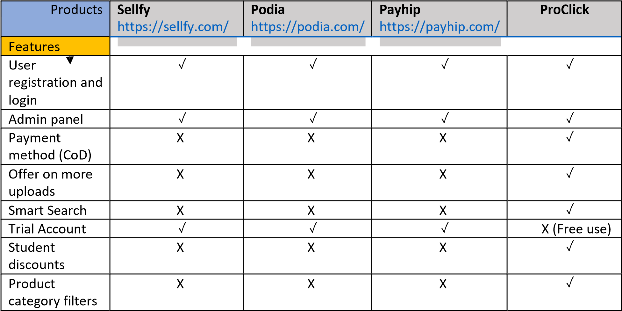

The above comparison shows the main features of existing competitors with our product and additional features that our product will offer. Since cash on delivery is being implemented as payment method, the user doesn’t have the headache of using debit/credit card or any other payment gateways while purchasing the items.

Smart search feature tracks and analyze the user search history to show the products he/she is most interested in. Buyer can see the number of views for his uploaded products.

Since other competitor platforms have limited trial accounts for the users, our product is free of cost and can be used for unlimited time period. It also offers student discounts on buying products.

## 1.7 High-level system architecture and technologies used

In order to provide the best possible platform to the users, we chose the following tools and technologies to develop the system:

* Server Host: Microsoft Azure (CPU: 210 ACU, Memory: 3.5 GB)
* Operating System: Linux
* Database: mySQL
* Webserver: Linux
* Server-Side Language: Node.js v16.15.0- Client-Side Language: Typescript React

Additional Technologies:

* Web Framework: Node Express• IDE: VS Code

Supported Browsers:

* Google Chrome
* Mozilla Firefox
* Safari
* Microsoft Edge

## 1.8 Teams and Roles

|  |  |
| --- | --- |
| **Team Member Name** | **Role** |
| Ahmed Hassan | Team Lead, Backend and Database Lead |
| Tarmah Iqbal | Frontend Lead |
| Mayank Chetan Parvatia | Backend Developer and Partial contribution in Frontend |
| Bilal Ahmad | Backend Developer |
| Abdullah Khalid | Github Master |

## 1.9 Checklist

|  |  |
| --- | --- |
| **Task** | **Status**  **(Done/On**  **Track/Issue)** |
| Team found a time slot to meet (online) outside of the class | Done |
| GitHub master chosen | Done |
| Team decided and agreed together on using the listed SW tools and deployment server | Done |
| Team ready and able to use the chosen back and front-end frameworks and those who need to learn are working on learning and practicing | Done |
| Team lead ensured that all team members read the final M1 and agree/understand it before submission | Done |
| GitHub organized as discussed in class (e.g. master branch, development branch, folder for milestone documents etc.) | Done |

# Milestone 2

## 2.1 Functional Requirements (Prioritized)

**Priority**

* *1 – must have*
* *2 – desired*
* *3 – opportunistic*

|  |  |  |
| --- | --- | --- |
| **Sr. no.** | **Functional Requirements** | **Priority** |
| 1. | Buyer can sign up and log in to the system using the university email | 1 |
| 2. | Buyer can search for the media by using Text and through Voice. | 1 |
| 3. | Seller can upload media in the form of image, audio, or video. | 1 |
| 4. | Buyer can download the media from the application | 1 |
| 5. | Seller can delete the media from the application which is uploaded by himself | 1 |
| 6 | Buyer can access media owned by him anytime e.g if it gets deleted from computer | 1 |
| 7. | Buyer can send messages to the seller to buy media. | 1 |
| 8. | Admin can view the media in the system | 1 |
| 9. | Admin can create new media in the system |  |
| 10. | Admin can delete media uploaded by the sellers | 1 |
| 11 | Admin can block certain users. | 1 |
| 12. | Admin can approve the media uploaded or updated by seller | 1 |
| 13. | Admin can view the list of buyers and sellers registered in the system | 1 |
| 14. | Sellers should be able to update the product’s details such as media, description, etc. | 1 |
| 15. | Buyer will get a bonus deposit on sign up. | 2 |
| 16. | Buyer can get recommended results based on his previous search or tags | 2 |

## 2.2 List of Main Data Items and Entities

|  |  |  |  |
| --- | --- | --- | --- |
| **Sr. No.** | **Entities** | **Data Items** | **Detail** |
| 1 | Admin | String | A system administrator is responsible for managing seller's profiles, as well as to approval of media. |
| 2 | Seller | String | This entity contains the seller’s information. |
| 3 | Reviews | String | When a buyer makes a purchase, there is a rating option to rate the seller’s content. |
| 4 | Chat | String | This feature connects the seller and the customer, allowing them to communicate with no trouble. |
| 5 | Buyer | String | It contains the buyer’s profile information |
| 6 | Media | String | This application’s most important feature is its media. So, in this entity, we’ll store media URLs of each product that will be linked with a specific buyer. |

## 2.3. UI Mockups and Storyboards

**UI for Landing Page**

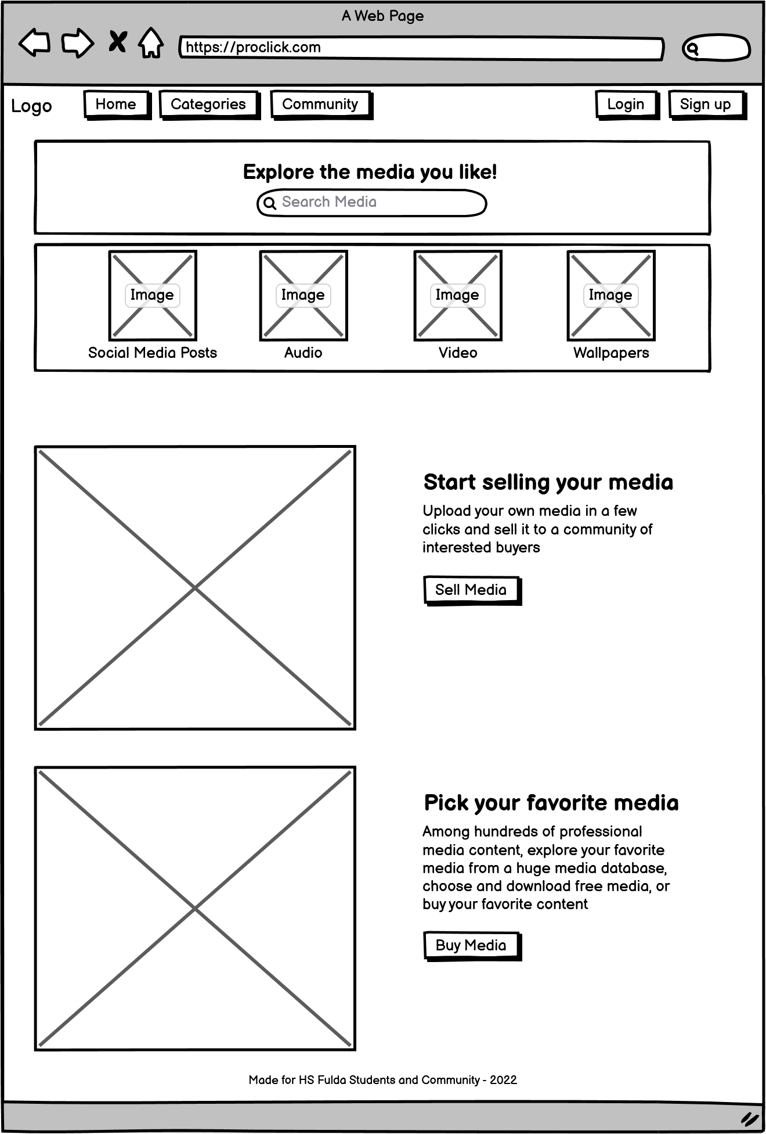

**S**

**ea**

**r**

**c**

**h**

**r**

**e**

**s**

**u**

**l**

**ts**

**11**

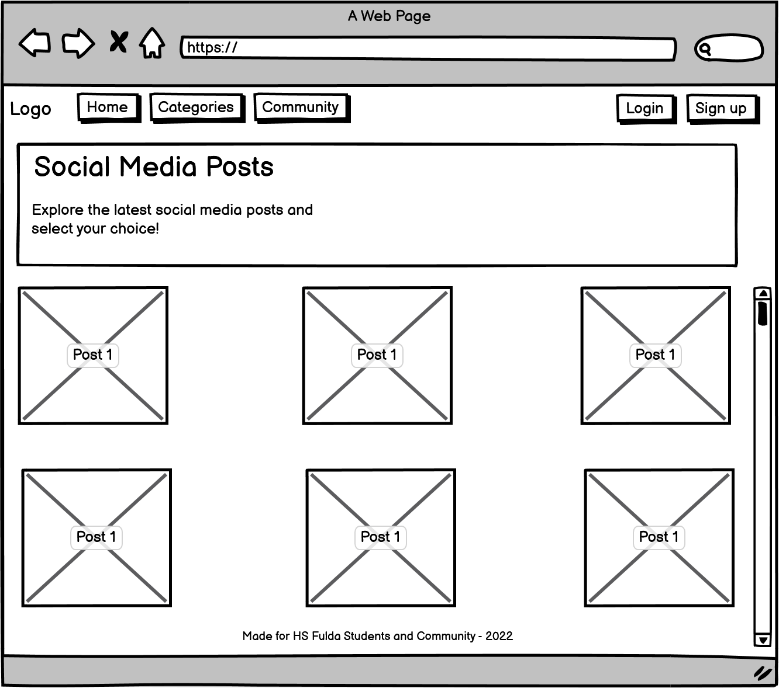

**UI for Item Details Page after clicking on a specific media item**

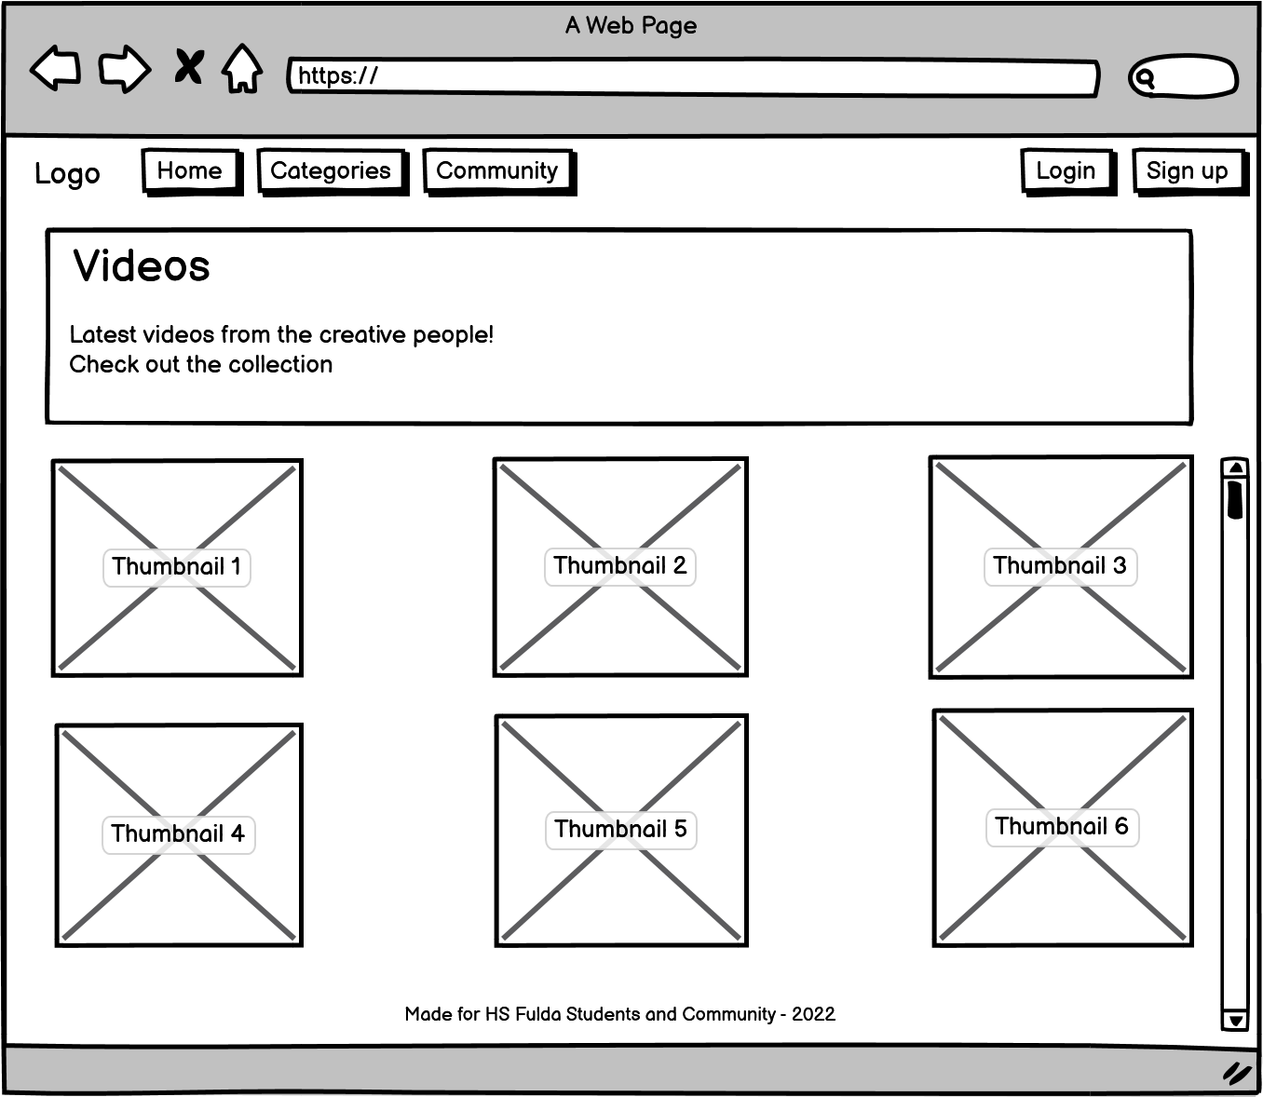

**UI for Item Details Page after clicking on a specific media item**

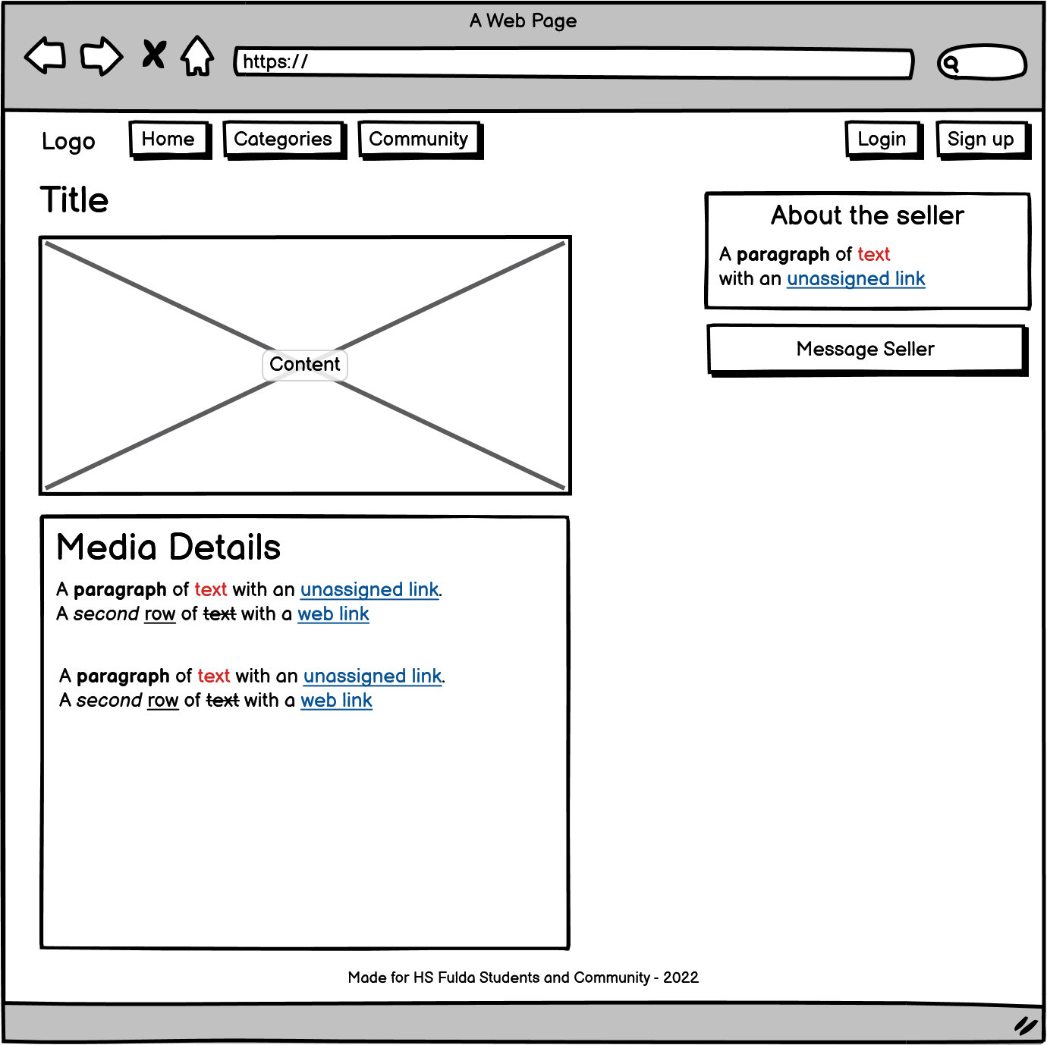

**UI for User Dashboard**

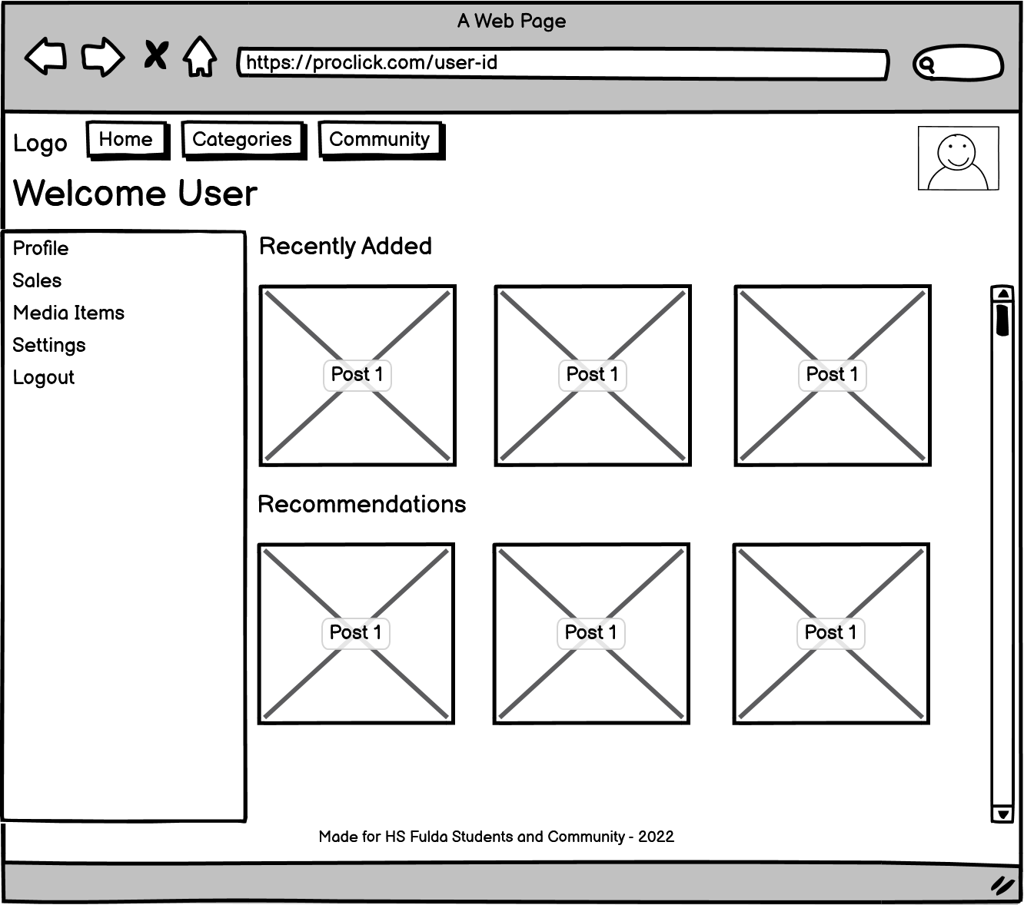

**UI for Item Details Page after login**

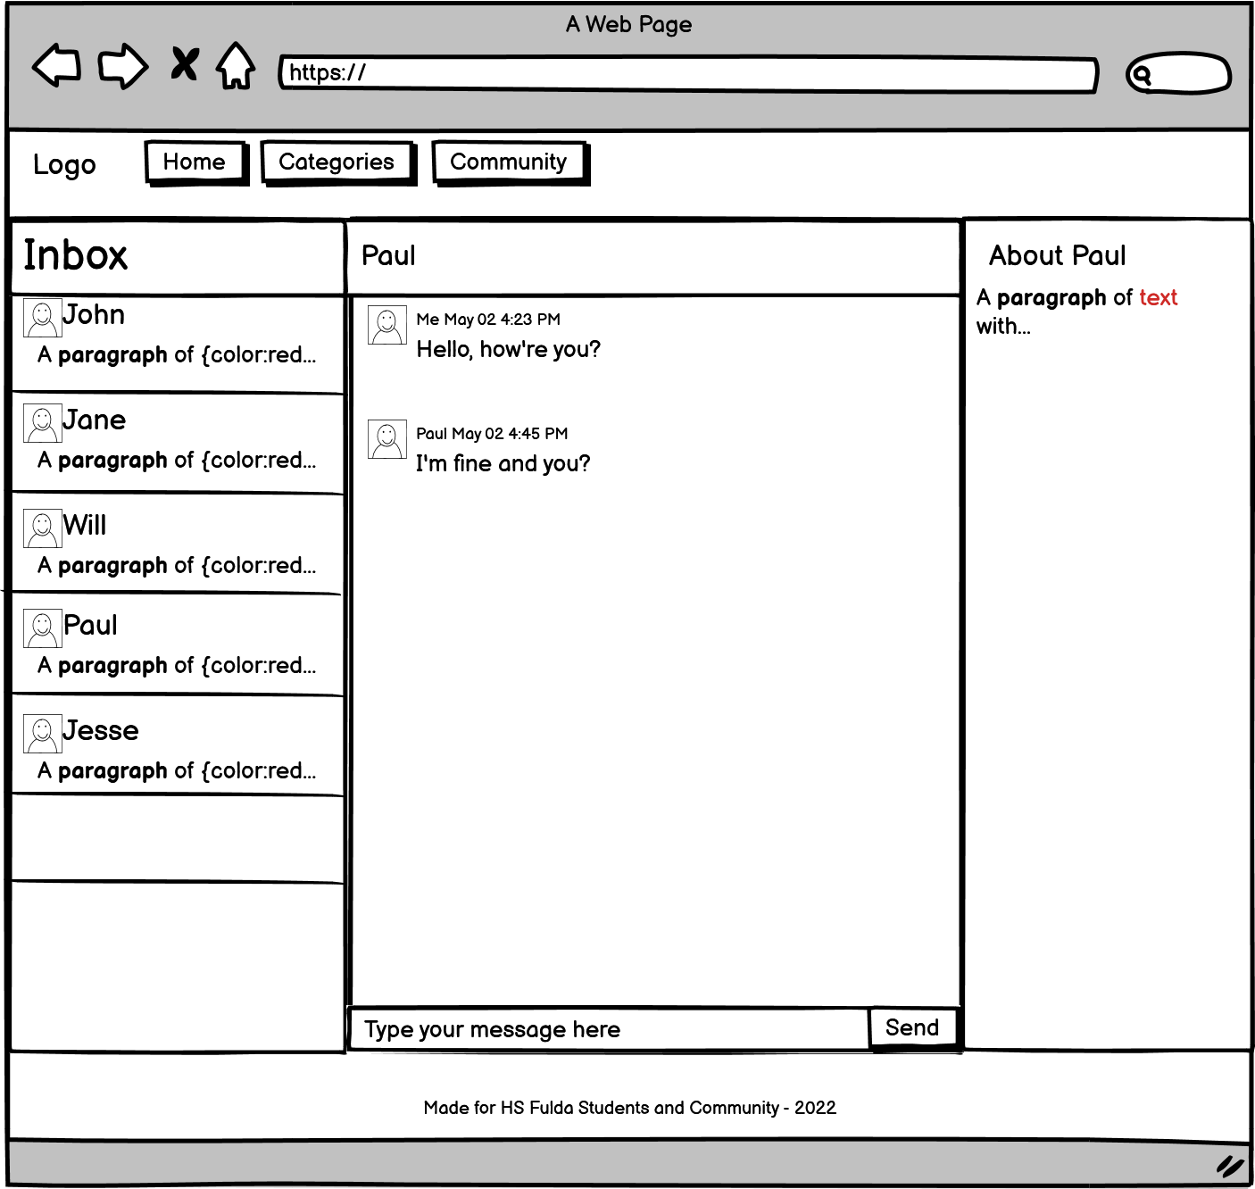

**UI for Item Details Page after login**

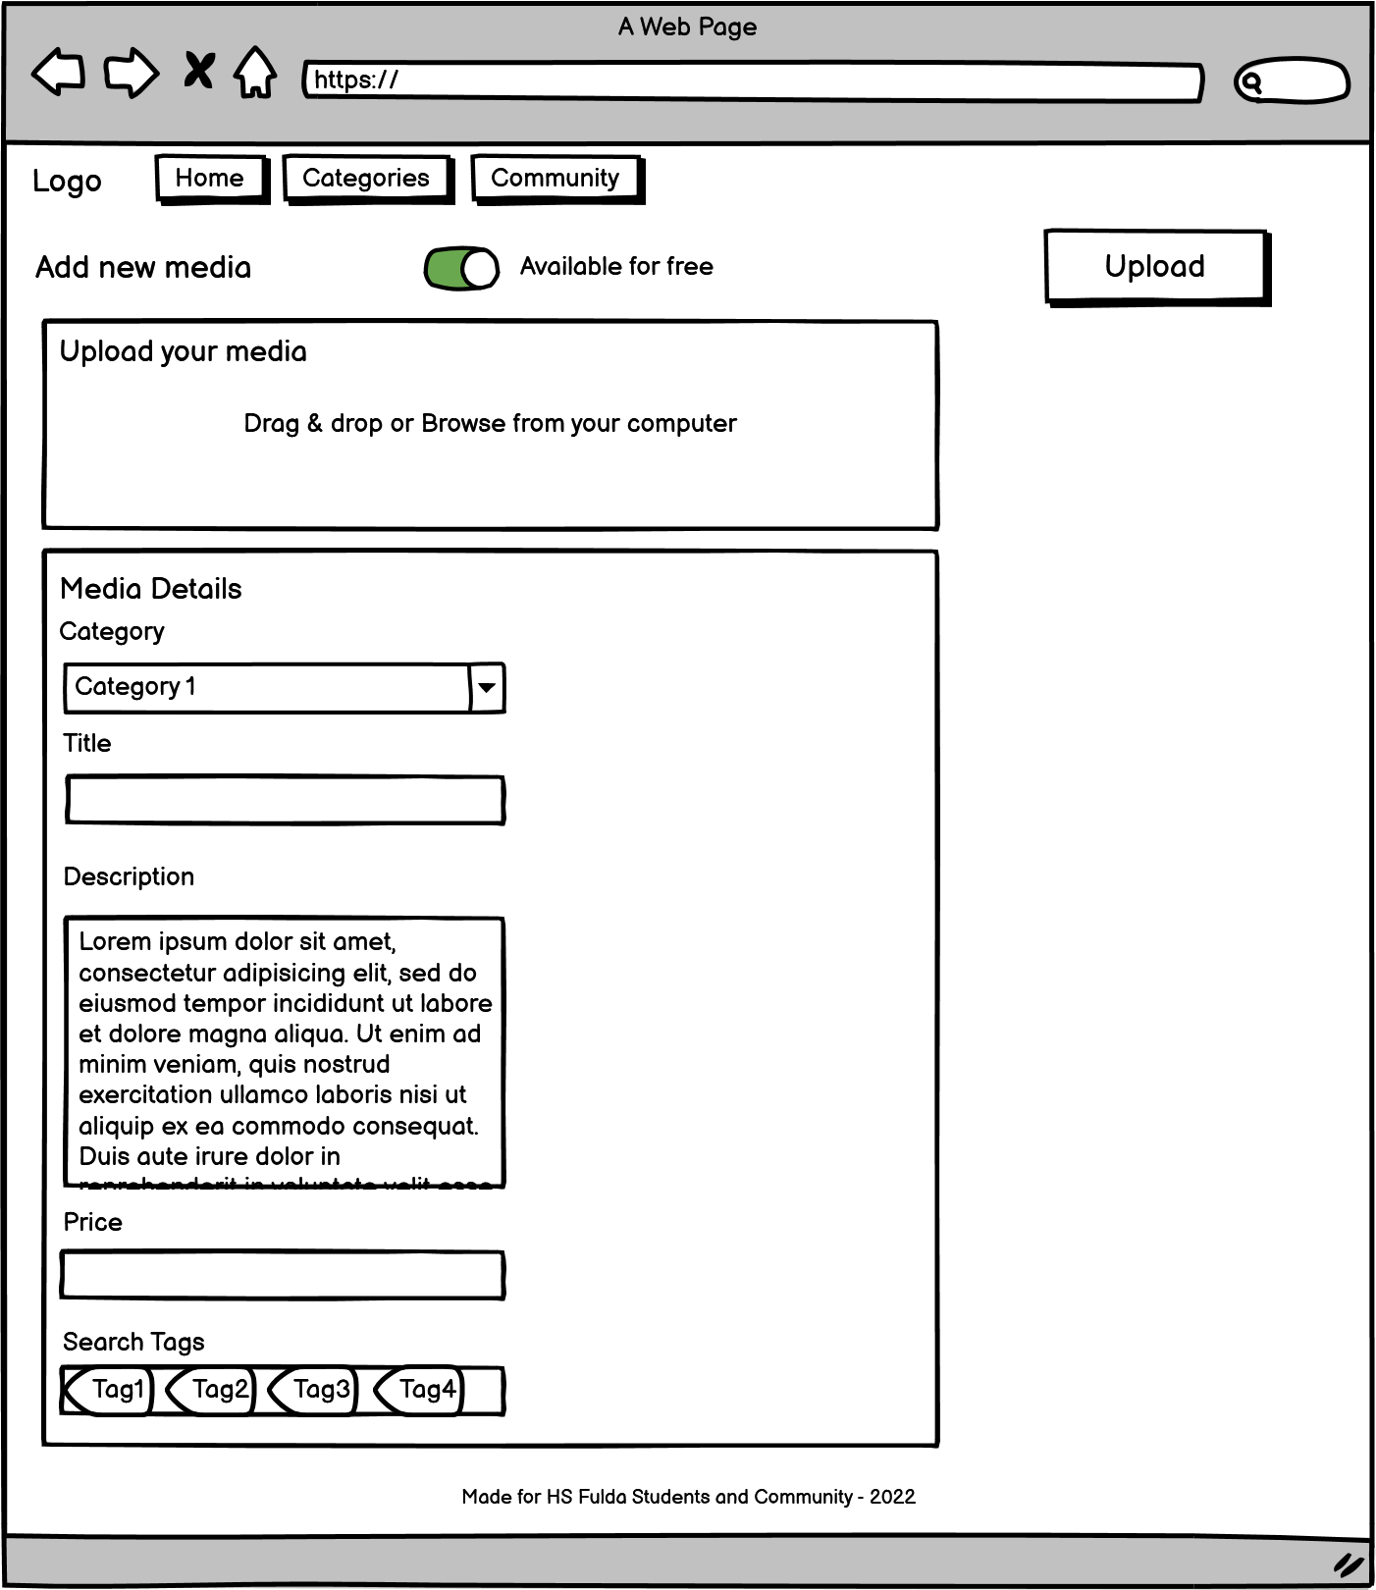

**UI for Admin Dashboard**

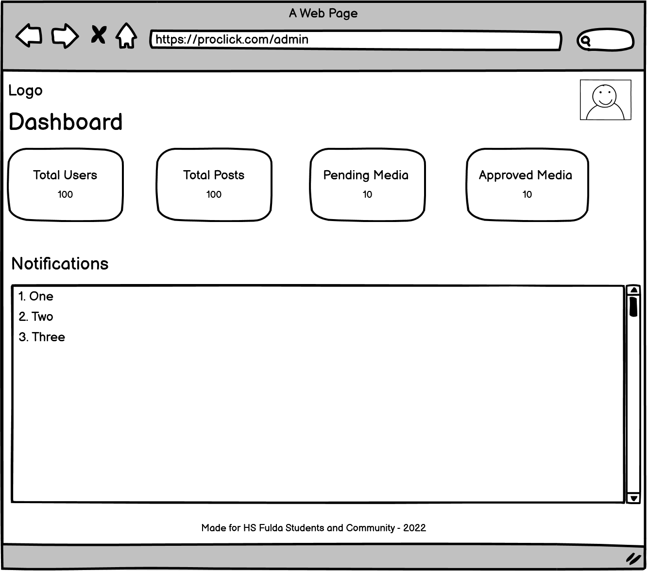

**UI for users list**

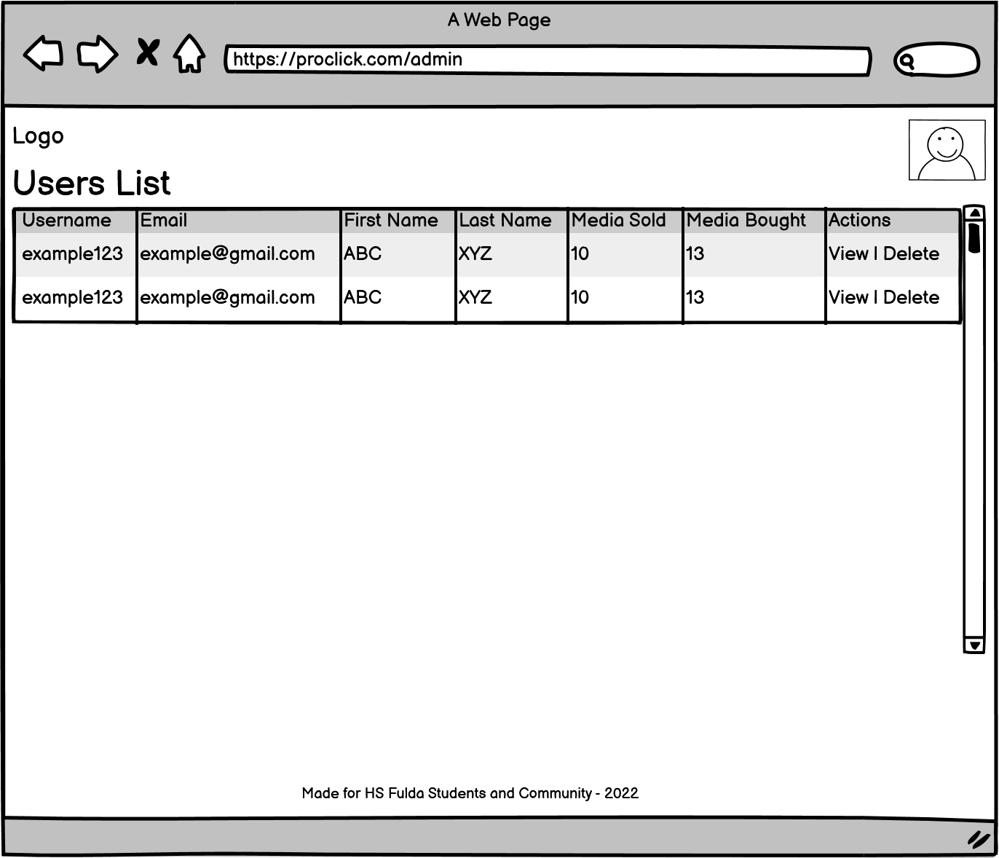

**UI for Media list**

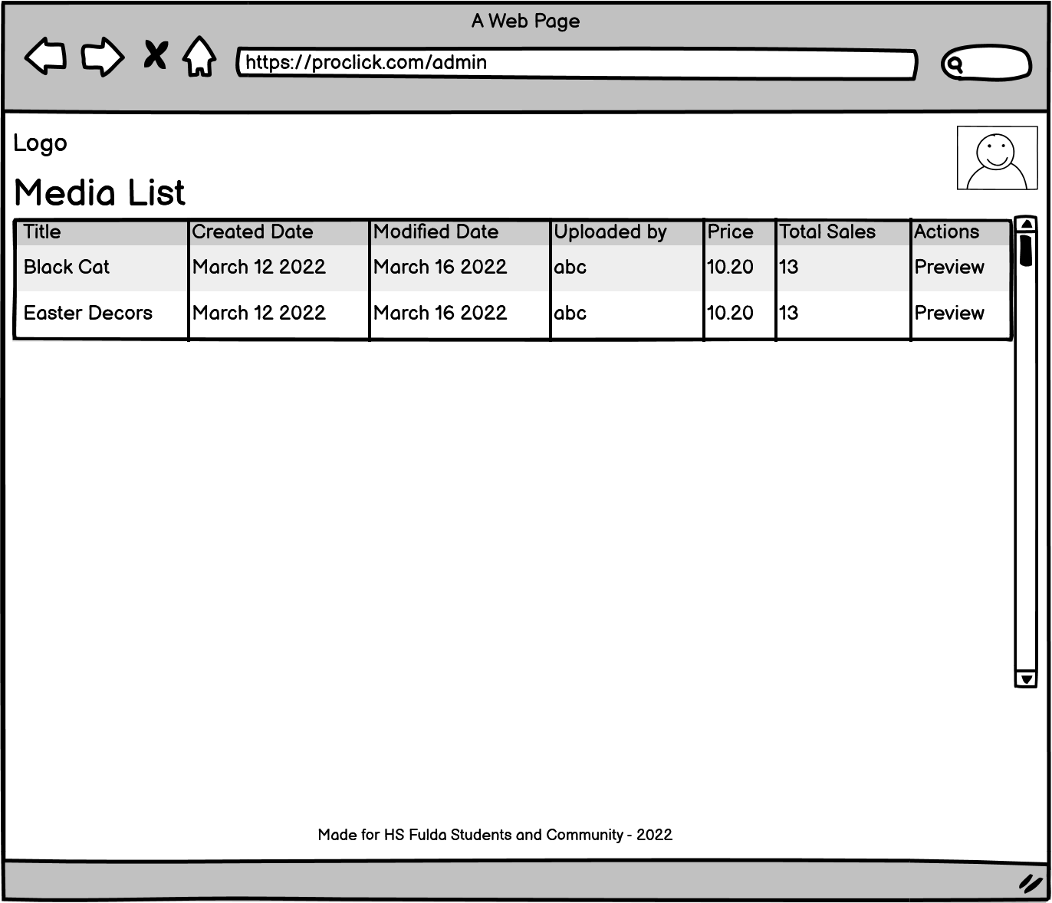

2.4 High Level Architecture, Database Organization

Database Organization

|  |  |
| --- | --- |
| **Database Table name** | **Attributes** |
| Tbl_user | User_id, username, email, password, first_name, last_name, profile_picture, about, is_seller, is_buyer, date_created |
| tbl_admin | Login_id, password, Name, profile_picture |
| Tbl_media | Media_id, title, media_category, sub_category, description, media_url, price, is_free |
| Tbl_messages | Msg_id, message, created_date, sender_id, sender_image, chat_id |
| Tbl_reviews | Review_id, media_id, level, comment, posted_by, posted_date |
| Tbl_user_search_history | Id, keywords, searched_by, date_searched |
| Tbl_sales | sale_id, media_id |
| Tbl_chats | Chat_id, created_date, thumbnail, |
| Tbl_ search_tags | Tag_id, name |

Media Storage

In order to store the data related to media items such as images, audio/video, we planned to use the **file system** on the server where the backend code of our application will be deployed. The sql database will store the media path (url) of the uploaded media. The image files will be stored as .png, video files as .mp4, and audio files as .mp3.

Search/filter architecture and implementation

Media search will be based on keywords the user will enter in the search bar. Each media item has a category associated with it that is used in retrieving the media on submitting a search query. For example, a picture of a cat is associated with the category “animal”, therefore when a user searches for animal, the picture(s) of all the animals including cats will be retrieved and shown to the user. The media table in the database contains a column named ‘category’ that stores the main category of the item.

For the prioritization of media items and show them to the users as suggested items, the user’s search history will be stored in the database and analyzed in order to get the appropriate results for a specific user. The ranking of the items will be based on the most viewed and most sold media and prioritized accordingly.

#### 2.5.High-levelUML Diagrams

Following are the high-level UML diagrams of our system. It gives the abstract overview of the main data items, classes, and their attributes. Also, it depicts the main components of the application and their connection to each other.

### 2.5.1. UML Class Diagram

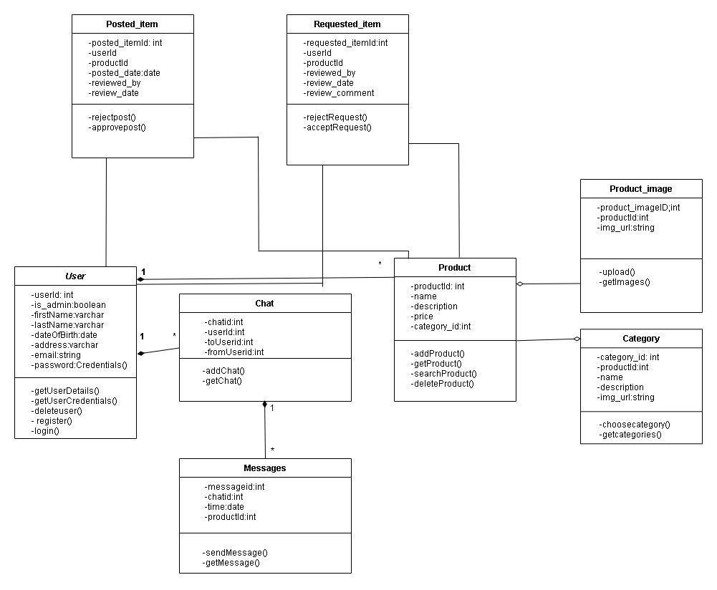

###### 2.5.2 Component Diagram

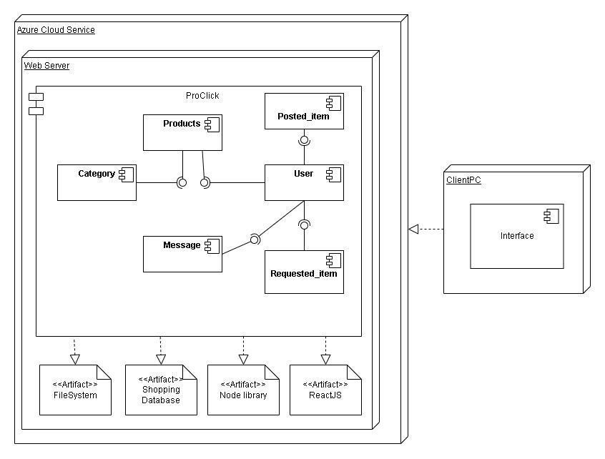

###### 2.5.2 use Case

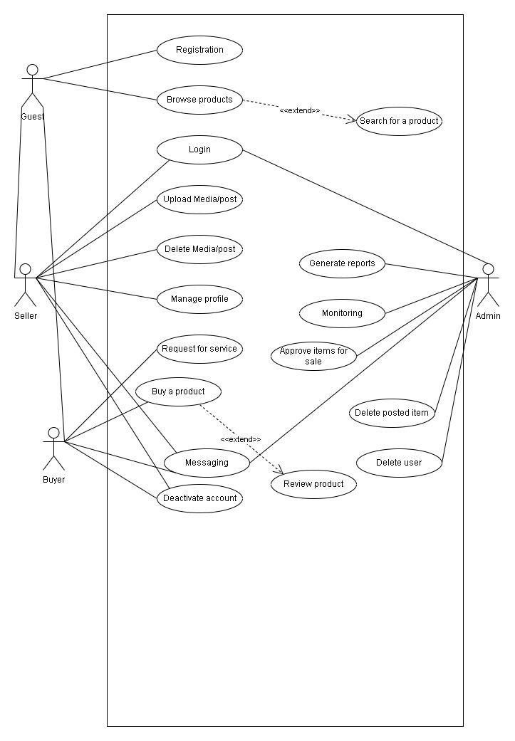

##### 2.6 Identify actual key risks for your project at this time

* Schedule

We had problem in arranging team meeting outside class. Everyone had different schedule going on before start of course e.g job, courses and other issues. We resolve it now after getting familiar with each other schedule and by having fixed team meeting schedule.

* Skills

We had problem in start for someone to help in backend side with main backend developer. We had front end side skills but for backend it was problem. We managed to overcome it initially by splitting backend in little chunks, so we can do it easily, but now we have another team member so issue is resolved in more good way.

* Technical

We don’t have any team member to do cloud deployment or deal with it. We struggle so much with it in start. We wasted our time also more in deployment on cloud and getting familiar with most if it, but we are managed to do it but collaborative efforts. Everyone searched on different cloud providers and share opinions and then we go with azure. No one was familiar with cloud deployment, so it was big issue in start.

## 2.7 Project Management

Since our team is comprised of 6 members and there are four main roles that are defined among the team members; backend team, frontend team, github master, and cloud engineer. To complete the milestone 2 and plan its future tasks, the sections of the milestone 2 document are divided among all the team members based on their roles and experience levels.

The team uses a communication channel to remain synced with the updates done by each of the members of the group. For the milestone 2 documentation, we are using google docs to add each member part in the cloud document so that every member can get an updated version of the document at any time. In case of any issue, the updates are shared in the communication channel and be resolved accordingly.

For the future tasks (development, testing and deployment etc.), we will be using Trello board in which the tickets will be generated and assigned to each member based on their roles. The board will be divided into 4 main sections; *To-Do, In-Progress, Review, Done*. Each member will move their assigned tickets to each section and show their progress.

# Milestone 3

Summary of Feedback and Tasks to do

This document of milestone 3 serves as a purpose of feedback of our team project for the distributed global software development. It follows the planning and analysis made in the milestone 1 and milestone 2 and summarizes the feedback and the progress our team has made so far. The application is now in working state and deployed on cloud. The structure of both the frontend and the backend has been made by following MVC architecture and good design principles.

All the code is managed on GitHub with separate branches of each of the group member and a main branch to merge and deploy the final code to the cloud. The database instance is also able to be connected by a SQL query editor tool Workbench.

For the next task(s), the milestone 3 document will be used to list down the Priority 1 requirements which are considered to be the core functionality of our application and after finalizing of those requirements, it will be locked and must be delivered as a final delivery.

## 3.1 List of tasks the team chose to focus on

|  |  |  |
| --- | --- | --- |
| **Sr. no.** |  | **Tasks** |
| 1. | Voice Search |  |
| 2. | Sign Up Bonus |  |
| 3. | UI/UX improvements |  |

## 3.2 List of final Product P1 functions agreed at the meeting

Since the functional requirements have already listed down in the previous milestone 2 document, the following is the list of priority 1 requirements that are taken from the main functional requirements and decided to be delivered as a core functions.

|  |  |  |
| --- | --- | --- |
| **Sr. no.** | **Priority 1 Requirements** | **Status** |
| 1. | User can sign up and log in to the system using the university email | Done |
| 2. | Buyer can search for the media by text-based input and voice. | Done |
| 3. | Seller can upload media in the form of image, audio, or video. | Done |
| 4. | Buyer can download the media from the application | Done |
| 5. | Seller can delete the media from the application which is uploaded by himself | Done |
| 6 | Buyer can access media owned by him anytime e.g., if it gets deleted from computer | Done |
| 7. | Buyer can send messages to the seller to buy media. | Done |
| 8. | Admin can view the media in the system | Done |
| 10. | Admin can delete media uploaded by the sellers | Done |
| 11 | Admin can block certain users. | Done |
| 12. | Admin can approve the media uploaded or updated by seller | Done |
| 13. | Admin can view the list of buyers and sellers registered in the system | Done |
| 14. | Sellers should be able to update the product’s details such as media, description, etc. | Done |
| 15. | Buyer will get a bonus deposit on sign up. | Pending |
| 16. | Buyer can get recommended results based on his previous search or tags | Pending |

# Milestone 4

## 4.1 Product Summary

**Name of the product: ProClick**

**Motivation & Importance**

E-commerce is the fastest growing business during the past decade, considering the circumstances now, it is indeed one of the rapidly growing phenomena in Pandemic. **ProClick** aims to provides a platform which brings buyers and sellers together encouraging social e-commerce within the university. We have seen enormous potential and growth during pandemic for used products and services and how natives are more inclined towards buying through online channels.

**Functions & Services**

Our mission is to provide a platform where users can sell and purchase images. Having a distinct search filters that refines user experience, also boosts customer retention, and increases user sales. ClickPro will increase customer satisfaction when consumers deal with sellers directly via built-in-messaging system provided in our platform where consumers can negotiate or ask for product or service-related questions from sellers. Our team is focused to provide a technology that will have an immense upside potential and we strive to improve the overall image of the online merchant and therefore stimulate growth of online shopping.

## 4.2 Major Committed Functions

1. **Browse products**

Image Listing page that shows a list of images based on category or search criteria.

1. **Filter images**

Specific attribute a visitor/shopper can use to refine the search results or images searches of a particular image list page. e.g., by category, price range etc.

1. **Search for a image**

Allowing/Enabling the customers to find certain images that satisfy / fulfill a criterion.Also allow the voice search.

1. **Registration**

Allowing the sellers and customers to make a new account profile for themselves.

1. **Login**

Allowing the customers and sellers to log in to their account or dashboard.

1. **Post images**

Allowing the seller to upload a new image for selling purpose from their dashboard / account.

1. **Messaging**

Allowing the customers and sellers to communicate with each other through messages and also enables them to see the previous message history as well from their dashboard.

1. **Approve/Reject items**

Allowing the admins / owners to approve / reject different pending products of different sellers from their dashboard.

**URL of the website: ProClick (the link may change due to redeploying)**

## 4.3 Usability Test Plan

* **Test objectives**

The objective of this testing is to get the user feedback and user experience about searching for a specific product using searched keywords, price range filter or choosing specific product category

* **Test background and setup**

**System setup**

ClickPro website have been published on AZURE to be tested by participants using the following technologies

* Operating System: Ubuntu 18.04 Server
* Database: MySQL v: 5.7
* Web Server: NGINX 1.18
* Server-Side Language: Node.js

Client-Side : ReactJS

**Starting point**

Participants will test ProClick website using their laptops or smartphones, and will focus on the search functionality in the home page

**The intended users :**

The test will be conducted with targeted category of users, which are the students and university employees of Fulda. Therefore, we will ask four users of the university to test the website

**URL of the system to be tested**

**ProClick** (the link may change due to redeploying)

* **What is to be measured**

We will be focusing on the user interaction with our app. How well he/she is using the app. Does he/she gets lost somewhere or don’t know what to do next

* **Tester 1**

**Phase: 1 Screening & Pretest**

**Q1. How old are you?**

28

**Q2. What is your profession?**

Student Service Consultant

**Q3. When was the last time you purchased an item online?**

Last week

**Q4. How often do you shop online?**

usually

**Q5. Which devices you usually you for online shopping?**

apparel

**Phase: 2 Usability Task description**

**Task 1:** Imagine tomorrow is your mother’s birthday and you are looking for some gift that ranges from 500 to 1000 $.?

**Task 2: Imagine** last week you.

**Task 3:** Imagine you have got bonus from your office for good work and wants to buy some beautiful pictures for your parents.

**Phase: 3 Post Test Questions**

**Q.1 What was your overall impression or experience when searching for a images that ranges from 50 to 100$**

It was a good experience, and I found the right one in the range of 50 to 100$.

**Q.2 What was the best or worst thing about searching for a specific product?**

The worst thing is that it is giving less choice to choose from and it is very difficult to know that whether the search works or not and it will be good if I will be able to use some other filters as well for searching. It will be good if I would be able to see sub-categories as well in searching option. **Q.3 How would you compare it with another competitor?**

I think it is a simple app but if I compare it with most of the online shopping platforms,they provides many filters and most of them don’t work properly but the good thing is that so far you have limited filters but at least they are working correctly.

**Q.4 How did you find the experience of using this website to complete this task?** It was a good experience, and I found the image I was thinking to buy easily.

**Sr.No Task Objective Scale 0/5**

|  |  |  |
| --- | --- | --- |
| **TASK 1 (Tester1)** | Search for Product using image filter | 4/5 |
| **TASK 2(Tester1)** | Search for Image using searched Keywords | 3/5 |
| **TASK 3(Tester1)** | Search for Image by choosing specific  category | 3/5 |

**Tester 2**

**Phase: 1 Screening & Pretest** **Q1. How old are you?**

23

**Q2. What is your profession?**

Software Engineer

**Q3. When was the last time you purchased an item online?**

Two days ago

**Q4. How often do you shop online?**

usually

**Q5. Which devices you usually use for online shopping?**

Laptop, mobile

**Phase: 2 *Usability Task description:***

**Task 1:** Imagine that After two weeks is the valentine day and you want to buy a gift for your girlfriend, and you are searching for some random gifts.

**Task 2:** Imagine that you found on the social media a very interesting book about Engineers and you want to buy it.

**Task 3:** Imagine that you want to practice some sports and you want to look for a bike.

**Phase: 3 Post Test Questions**

**Q.1 What was experience when you were searching for a random product?**

I could not find the product without selecting a category which I realized that I get all the products if my search is not available, but it is better to do something like an alert or error to let the user know what happened after he/she did the search

**Q.2 What was the best or the bad thing about searching for a specific image?**

The worst thing that I could not understand what happened after clicking on search button and as I mentioned before it should be an alert for the user to know what happened after any search, he/she did. The best part is that I got my image, and it was displayed in a good way.

**Q.3 How would you compare it with other competitors?**

It is till now a very basic website, but what you achieved in this specific and limited time is very impressive by implementing all the functionality and the best part is the search functionality even with limited filtering was working, and If I want to compare it with other competitors it should be fully functional and also voice search make it more efficient.

**Q.4 How did you find the experience of using this website to complete this task?**

My experience was good regarding the search functionality and the result that I got, but you can do better guys.

**Sr. No Task Objective Scale 0/5**

|  |  |  |
| --- | --- | --- |
| **TASK 1 (Tester2)** | Search for a random Image without selecting a  category | 2/5 |
| **TASK 2(Tester2)** | Search for Image using price filter | 3/5 |
| **TASK 3(Tester2)** | Search for Image by using search keywords | 3/5 |

**Tester 3**

**Phase: 1 Screening & Pretest**  **Q1. How old are you?**

24

**Q2. What is your profession?**

Master Student at Fulda University

**Q3. When was the last time you purchased an item online?**

Month ago ***ProClick Project Documentation***

**Q4. How often do you shop online?**

usually

**Q5. Which devices you usually you for online shopping?**  mobile

**Q6. Have you ever used the similar site before?**

yes

**Phase: 2 *Usability Task description:***

**Task 1:** Imagine that After two weeks is the valentine day and you want to buy a gift for your boyfriend, and you are searching for some random gifts.

**Task 2:** Imagine that you are tired of your old wallpapers and now looking for a new for your room **Task 3:** Imagine that you got your salary slip and wants to buy a new wallpapers.

**Phase: 3 Post Test Questions**

**Q.1 What was experience when you were searching for a random images?**

No feedback or animation shows that the search is working especially when there is no result and return everything (like page refresh). It feels like the search button is not working. At least it should show at the header “no matching result found for the search Criteria”

**Q.2 What was the best or the bad thing about searching for a specific image?**

The best part is that the interface is user friendly and easy to use, but needs to improve the search fields and would it lovely to have auto complete which helps in search, also It’s better to show “Please Select Category” instead “No Category Selected” , and the price filter should be improved like using a slider component **Q.3 How would you compare it with other competitors?**

***ProClick Project Documentation***

It is a simple website, but what you achieved in this specific and limited time is very impressive.

**Q.4 How did you find the experience of using this website to complete this task?**

My experience was very good regarding the search function and it is very well placed at the top and have clear criteria separation

**Sr. No Task Objective Scale 0/5**

|  |  |  |
| --- | --- | --- |
| **TASK 1 (Tester2)** | Search for a random Image without selecting a  category | 3/5 |
| **TASK 2(Tester2)** | Search for Image using price filter | 2/5 |
| **TASK 3(Tester2)** | Search for Image by using search keywords | 3/5 |

## 4.4 QA Test Plan

* **Test Objectives**

The test objectives are to verify the Functionality of website ProClick, the project should focus on testing the search for images to guarantee this functionality can work normally in real business environment and to ensure that the bugs/issues are identified and fixed before going live

* **HW and SW setup**

Laptop and smartphones using Firefox and chrome web browsers

* **Feature to be tested**

All the functionalities of the website should be tested and verified, but will concentrate on the “search for a images” feature

* **QA Test plan**

|  |  |  |  |  |  |  |
| --- | --- | --- | --- | --- | --- | --- |
| **2** | Search for products of a specific category | Search for products of the furniture category | In the search fields, choose category “Furniture” | Retrieves all the furniture active products | **🗸** | **🗸** |
| **3** | Search for products within a price range | Search for products of the furniture category within (200- 1500) euro | In the search fields, choose min price 200 and max price  1500 | Retrieves all the active products that its price is within the specified range | **🗸** | **🗸** |
| **4** | Search for unavailable product | Search for a product that doesn’t exist in the ProClick | In the search fields, enter “Cat” in the name field. | Retrieves all the active products as there is no product available with the specified criteria | **🗸** | **🗸** |

|  |  |  |  |  |  |  |
| --- | --- | --- | --- | --- | --- | --- |
| **Test #** | **Test Title** | **Test Description** | **Test Input** | **Expected Result** | **Test**  **Results/Chro me** | **Test**  **Results/**  **Firefox** |
| **1** | Search for a specific  Image | Search for a specific image by its name | In the search fields, enter “Cat” in the name field | Retrieves all the active images that have Cats. | **🗸** | **🗸** |

|  |  |  |  |  |  |  |
| --- | --- | --- | --- | --- | --- | --- |
| **5** | Clear Search Criteria | Remove all the search criteria | Press the clear button | Retrieves all the active products  without any filtration | **🗸** | **🗸** |

4.5 Product screenshots

Sign in page

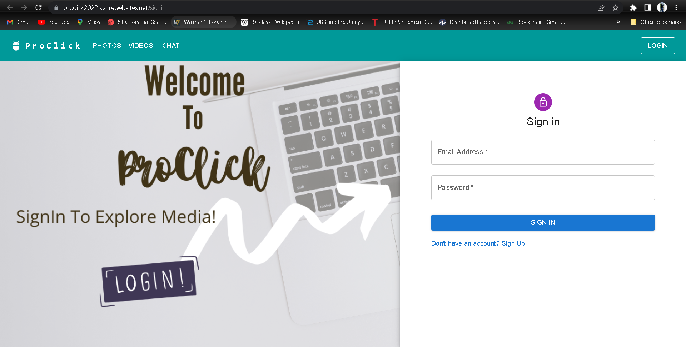

Sign up page

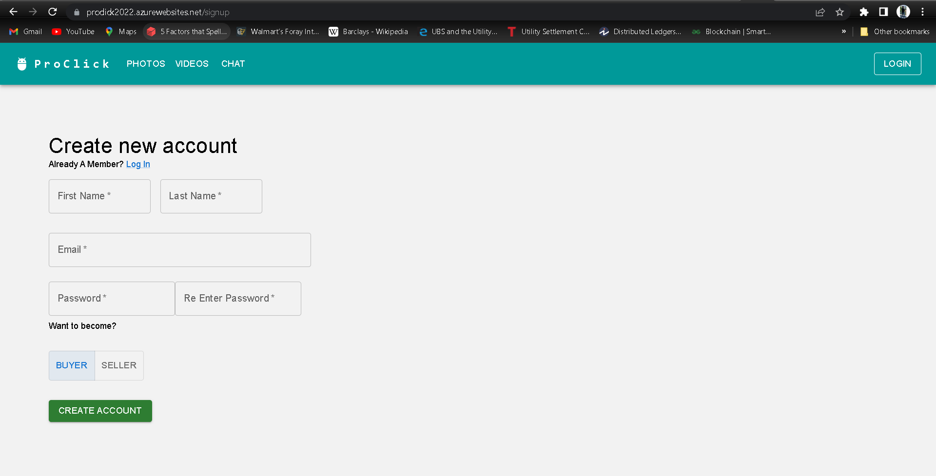

Seller

Seller/Upload media

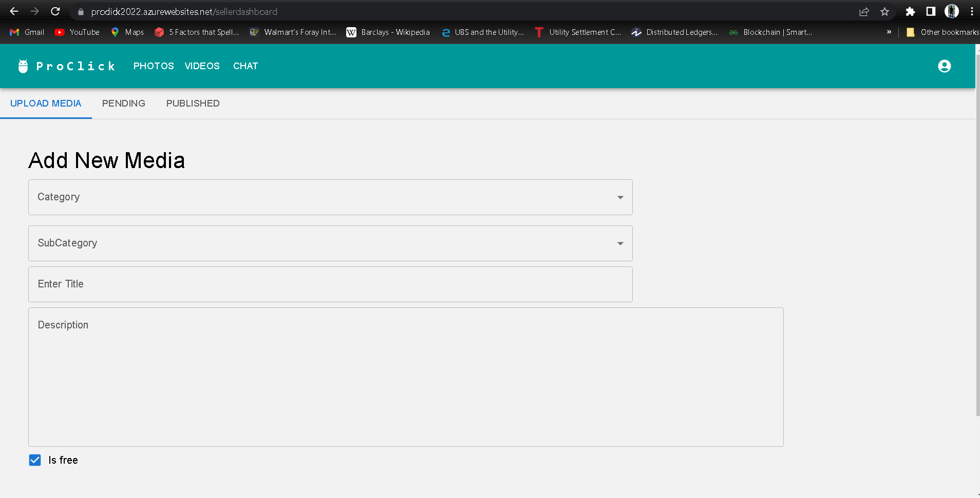

Seller/Pending media

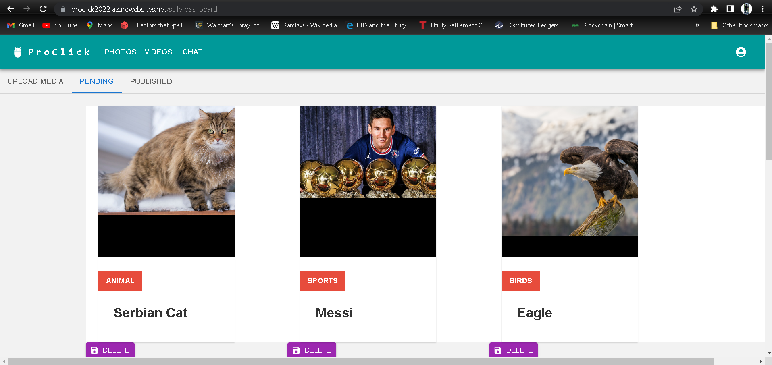

Seller/published media

Seller/update media

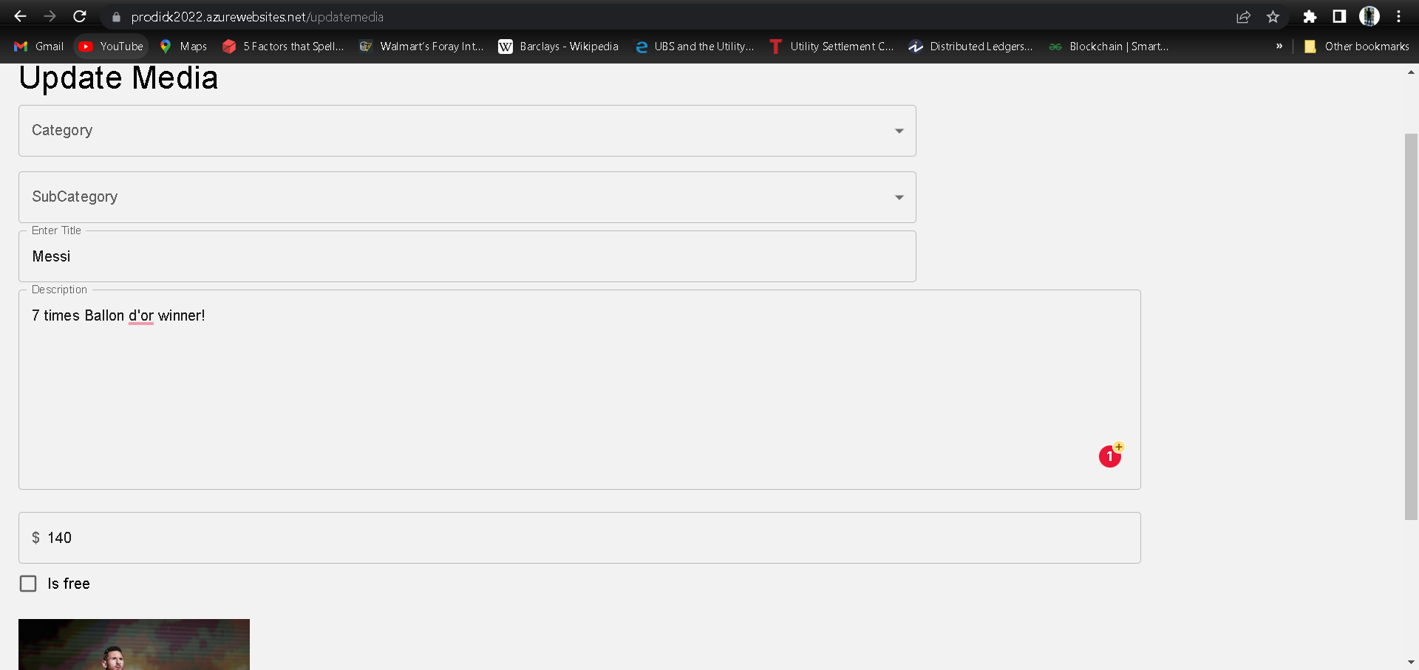

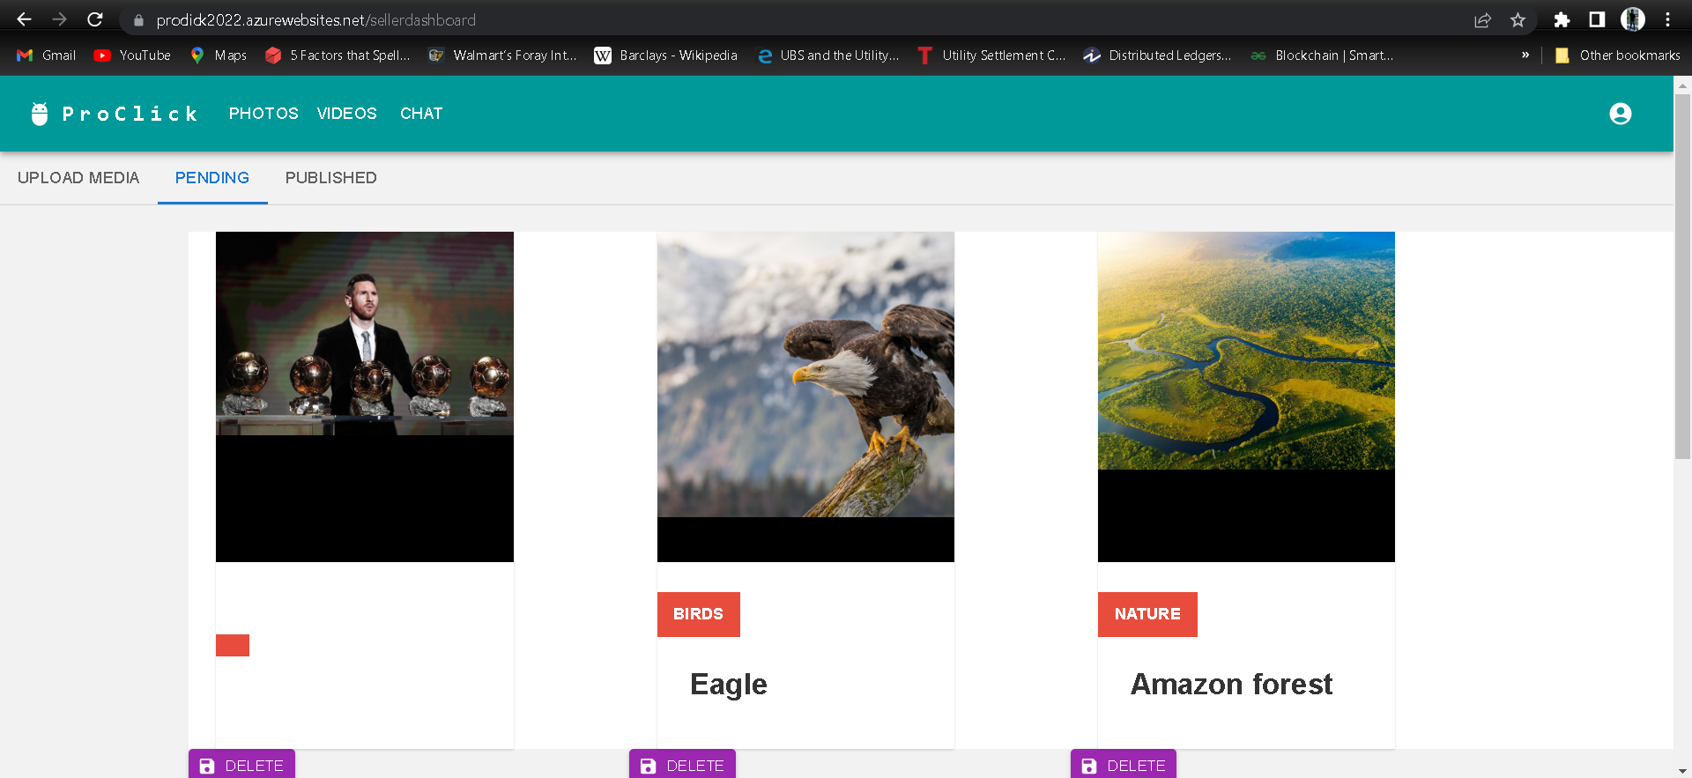

Admin

Admin/pending media

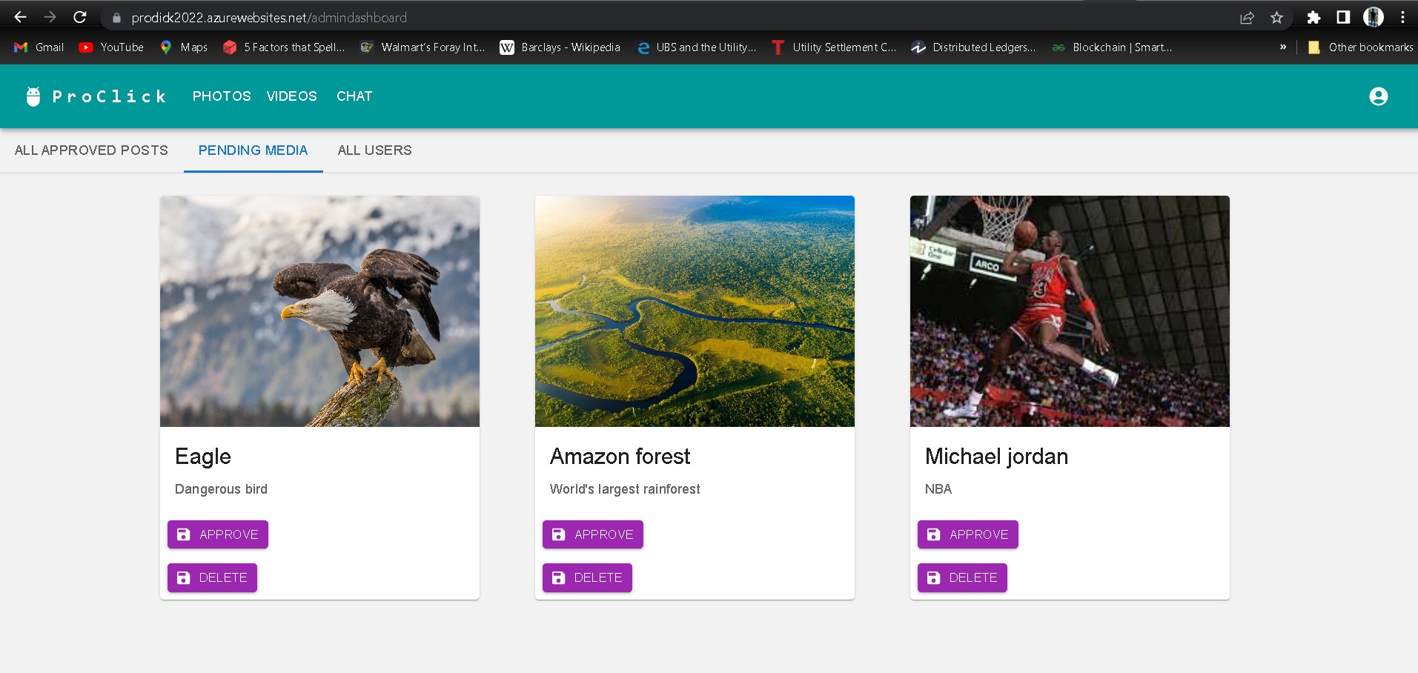

Admin/All users

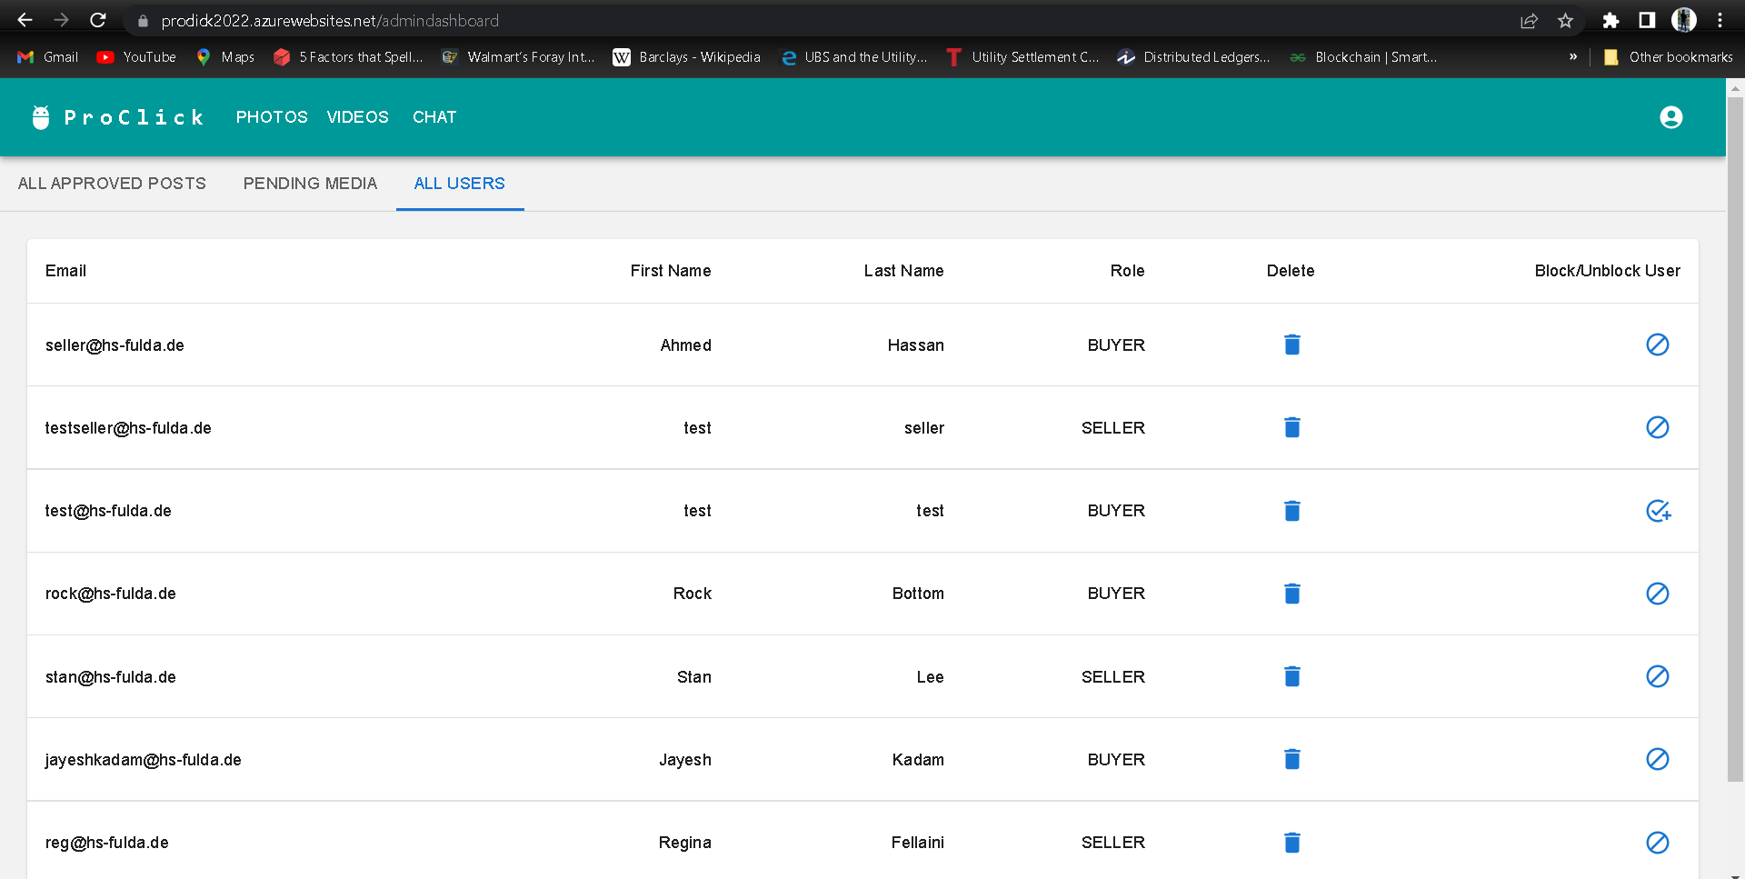

Buyer

Buyer/user details

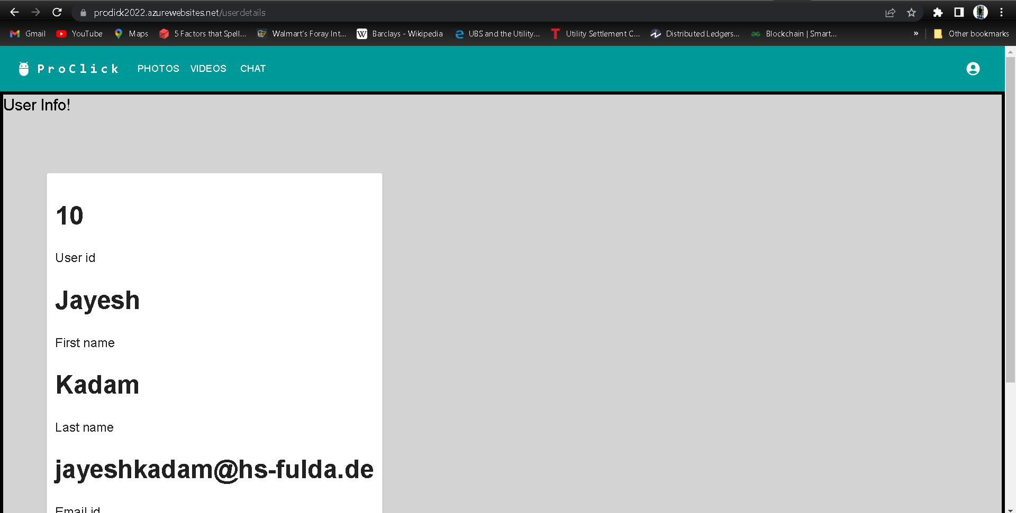

Buyer/review

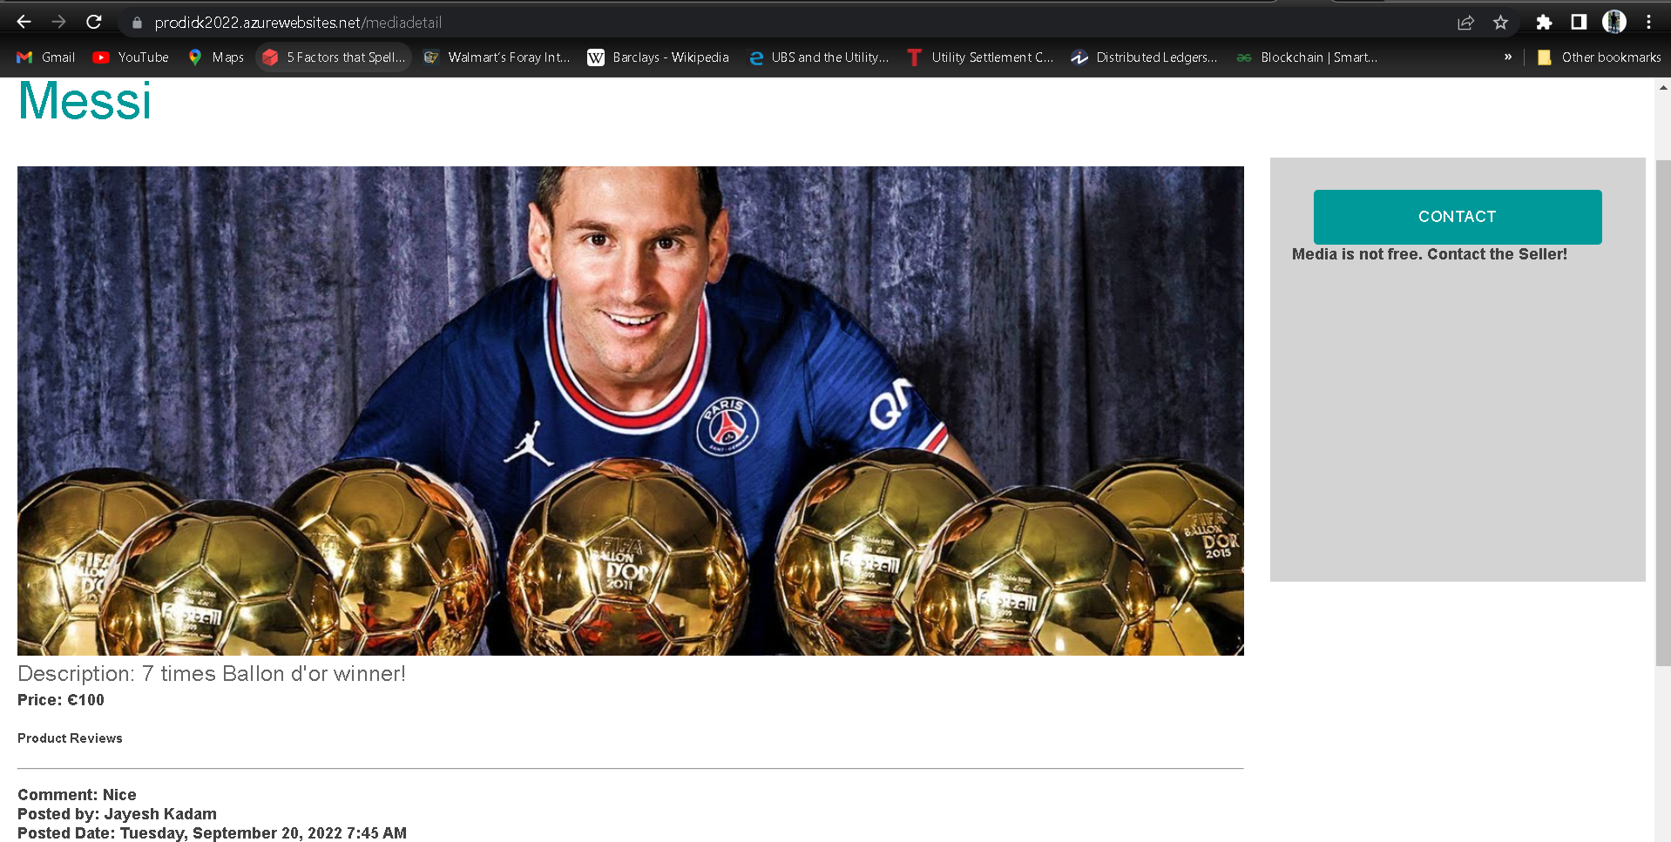

Chat

Chat/buyer

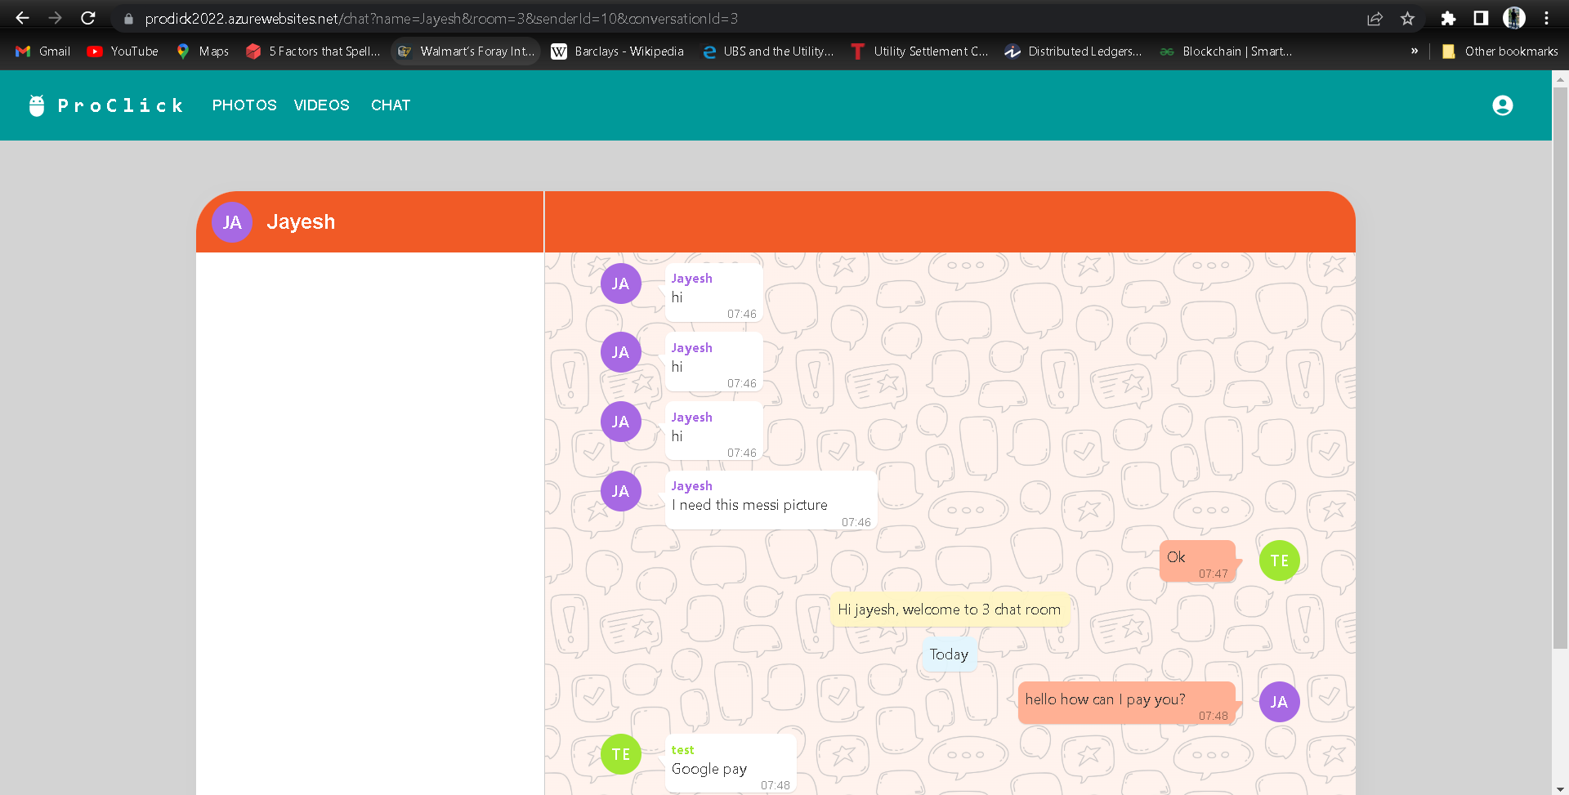

Chat/seller

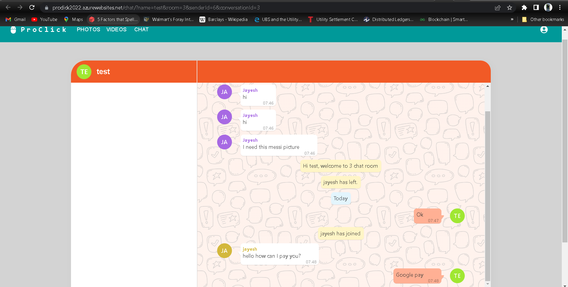

Change password

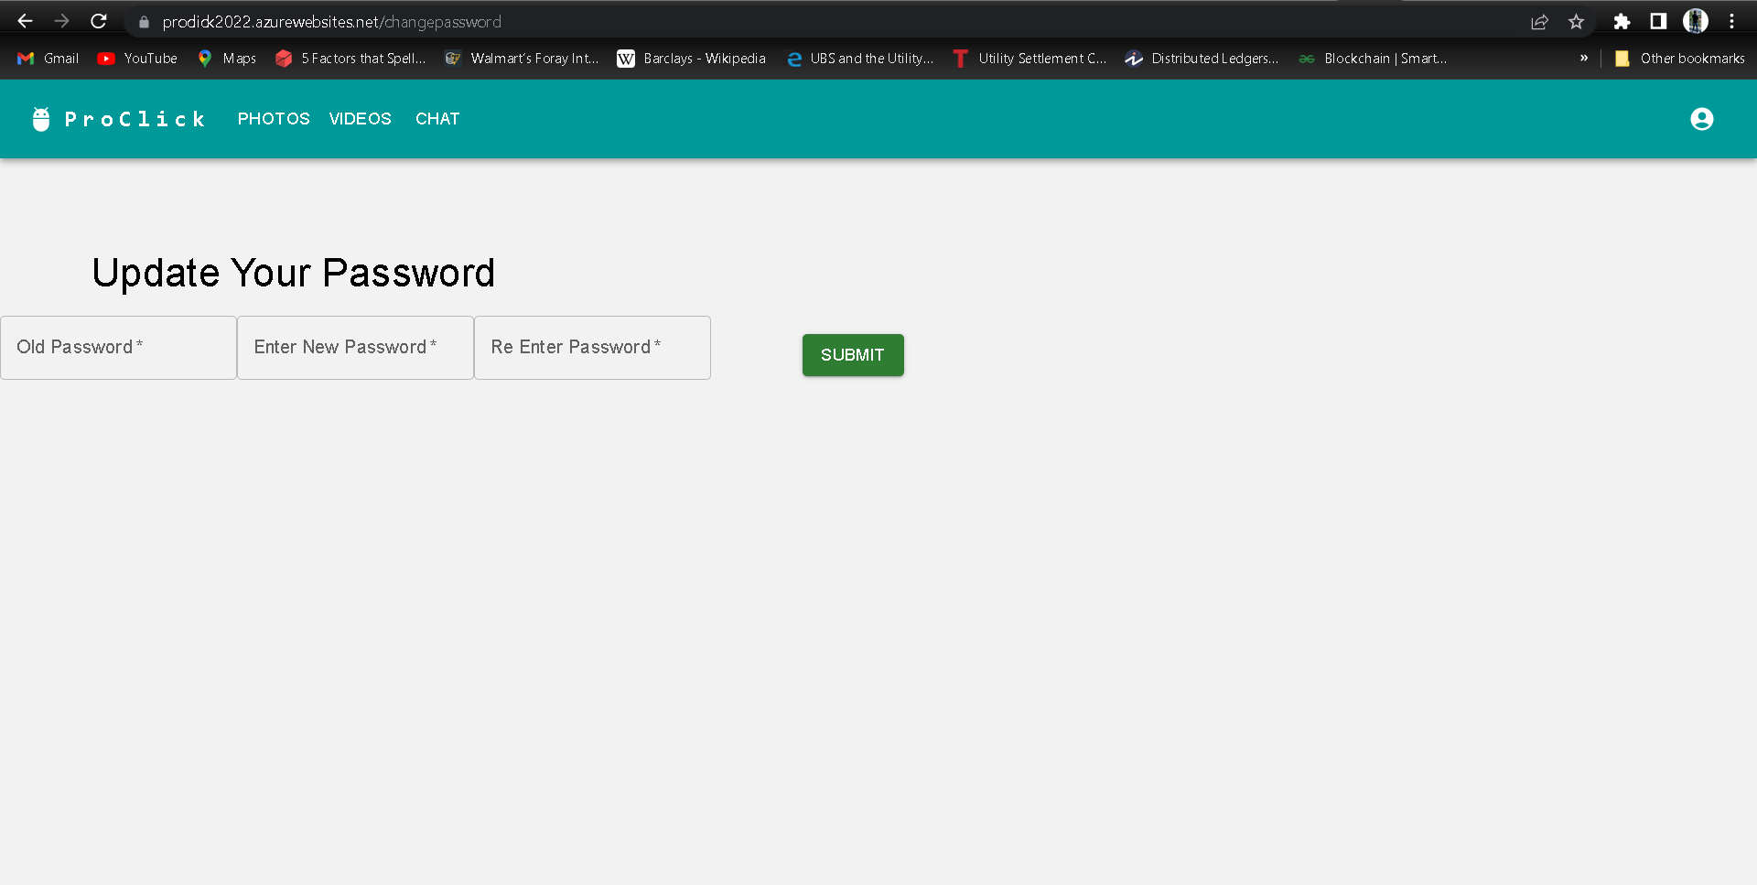

## 4.6 Code Review

* Done by Hamza Mazhar
* Reviewed by Ahmad Hassan

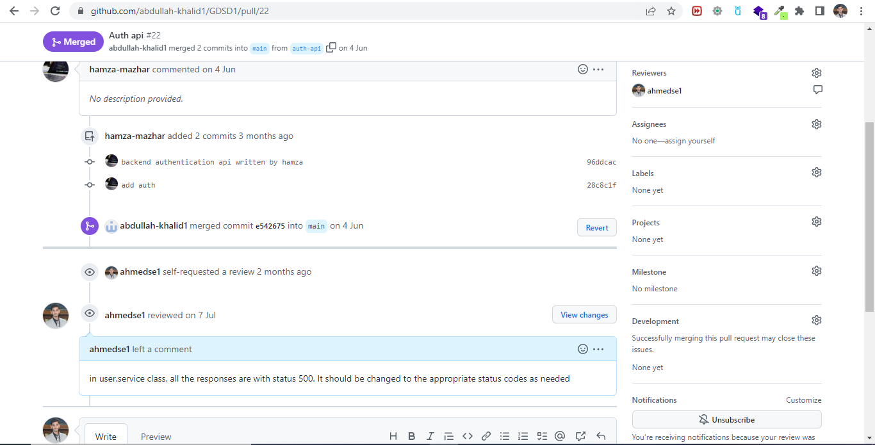

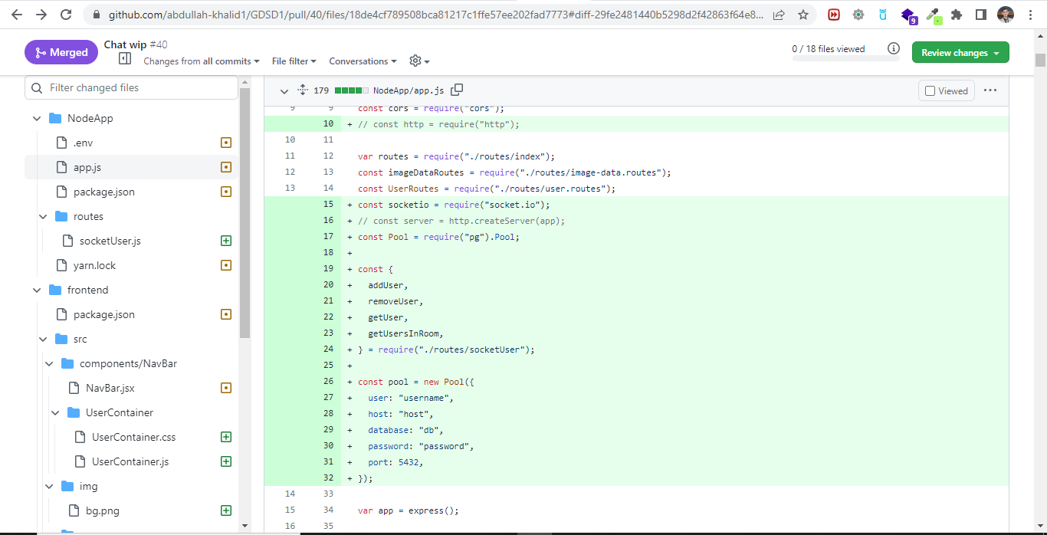

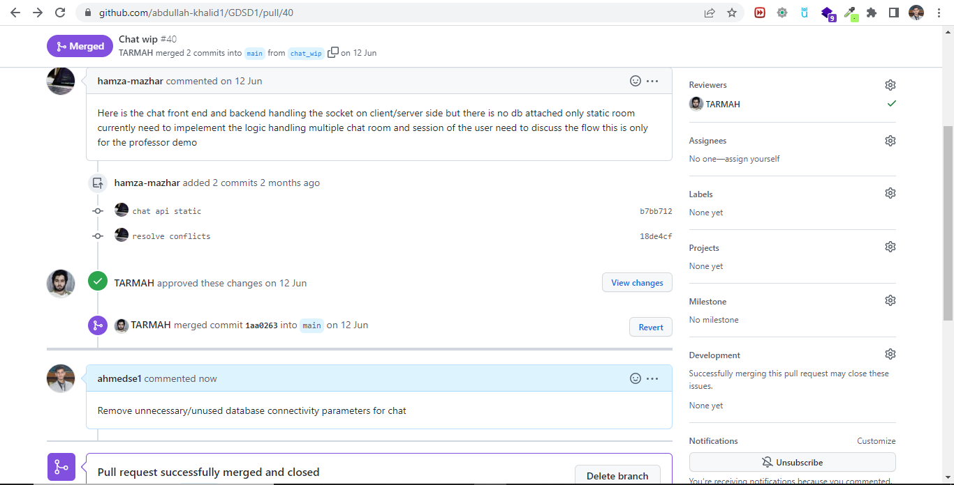

* Done by Ahmad Hassan
* Reviewed by Hamza Mazhar

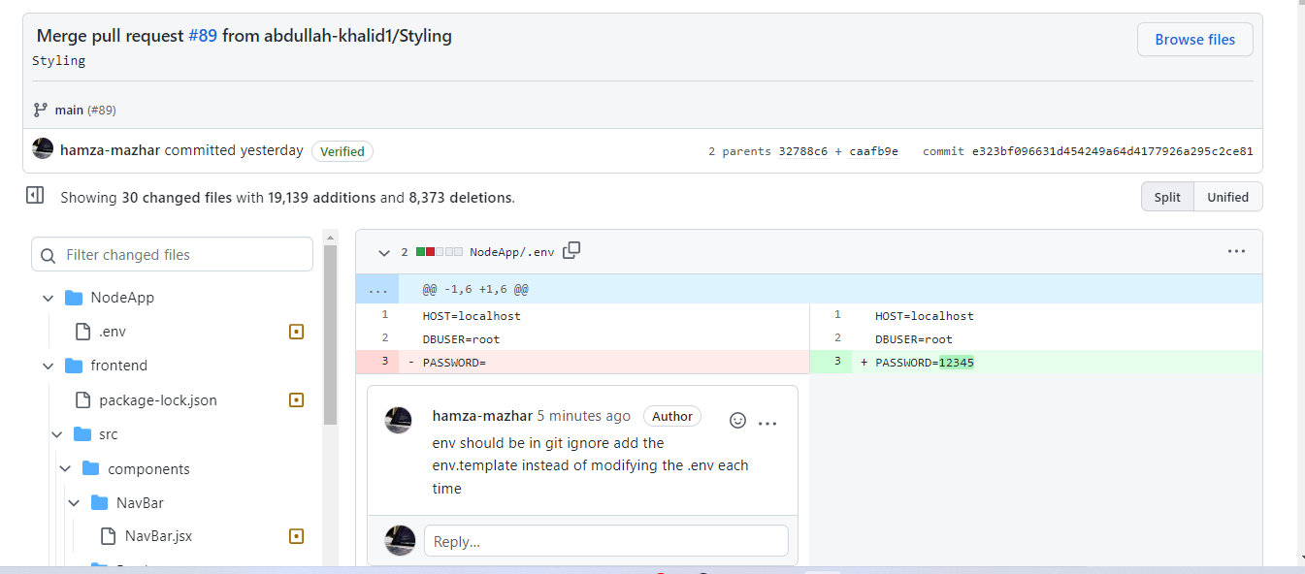

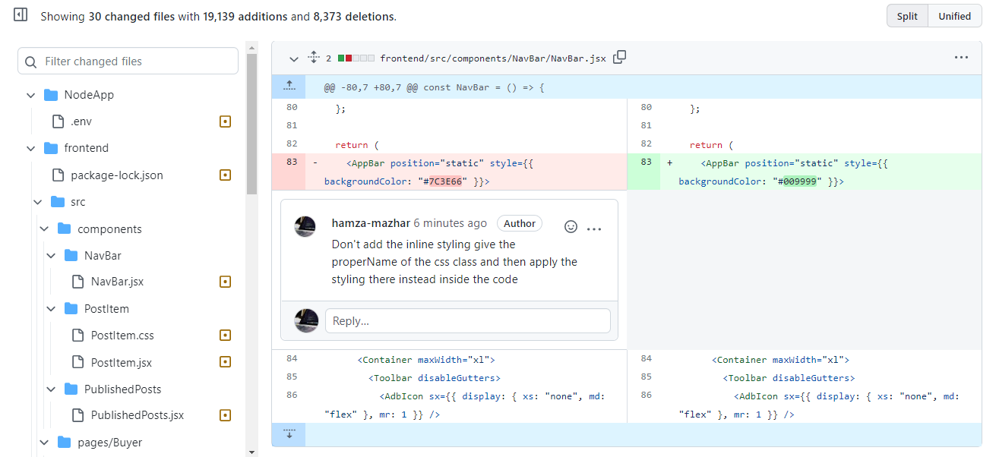

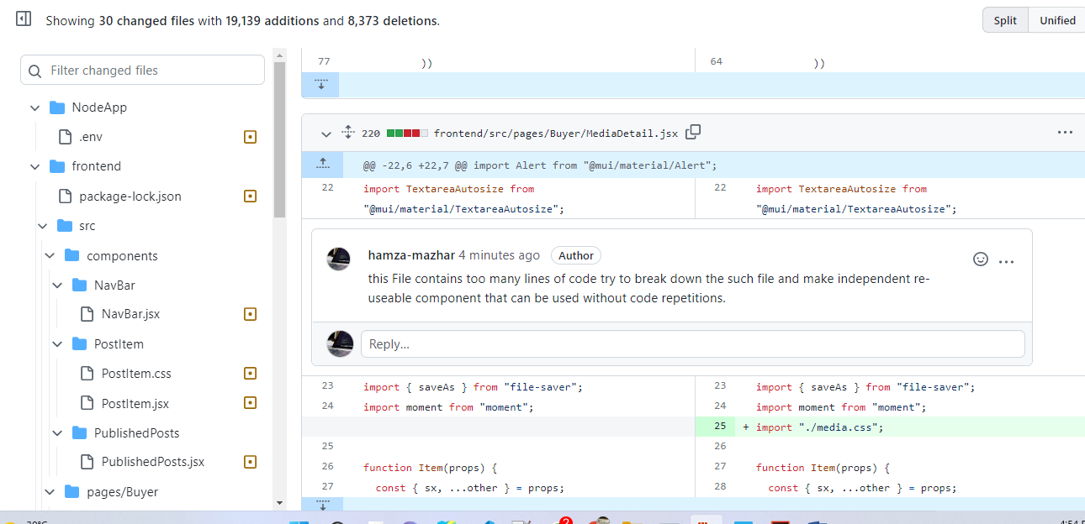

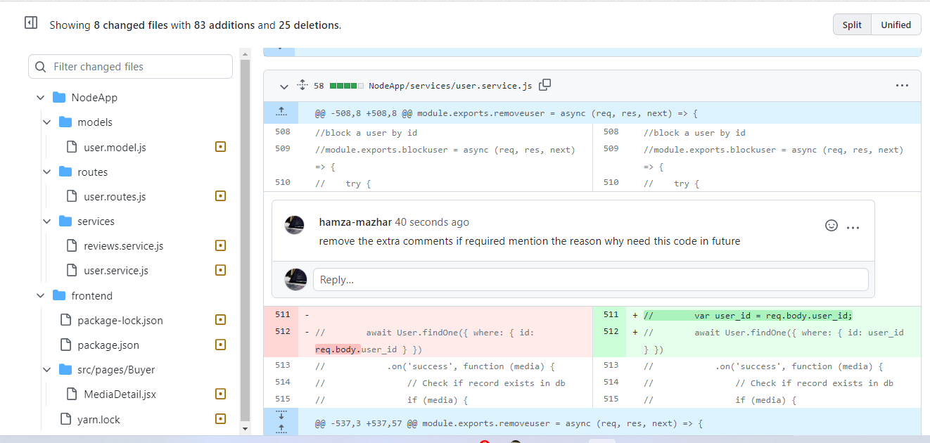

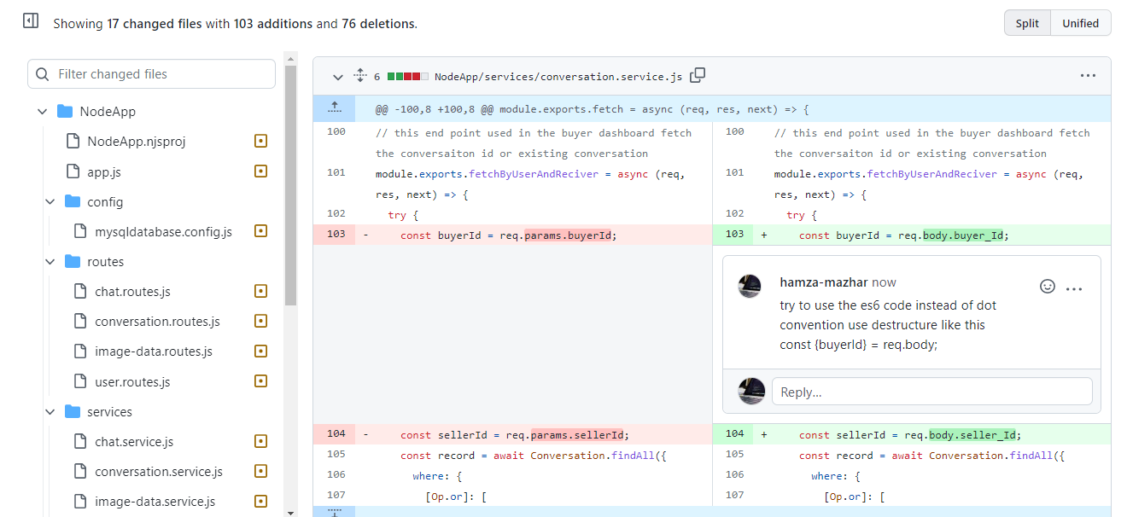

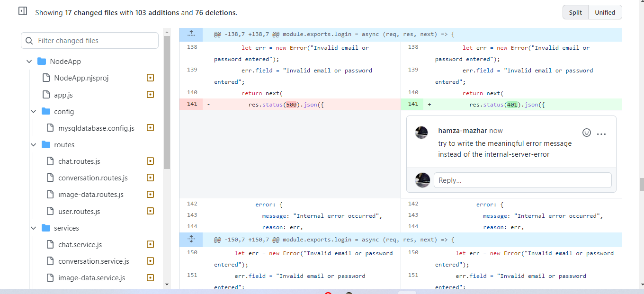

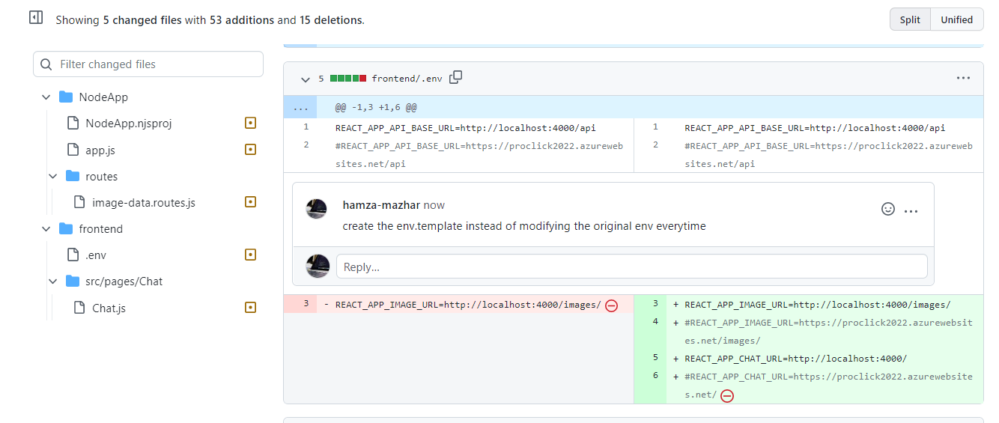

* Done by Tarmah bin Iqbal and Abdullah khalid

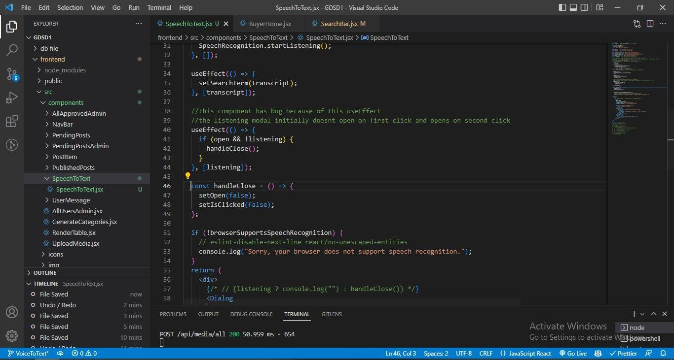

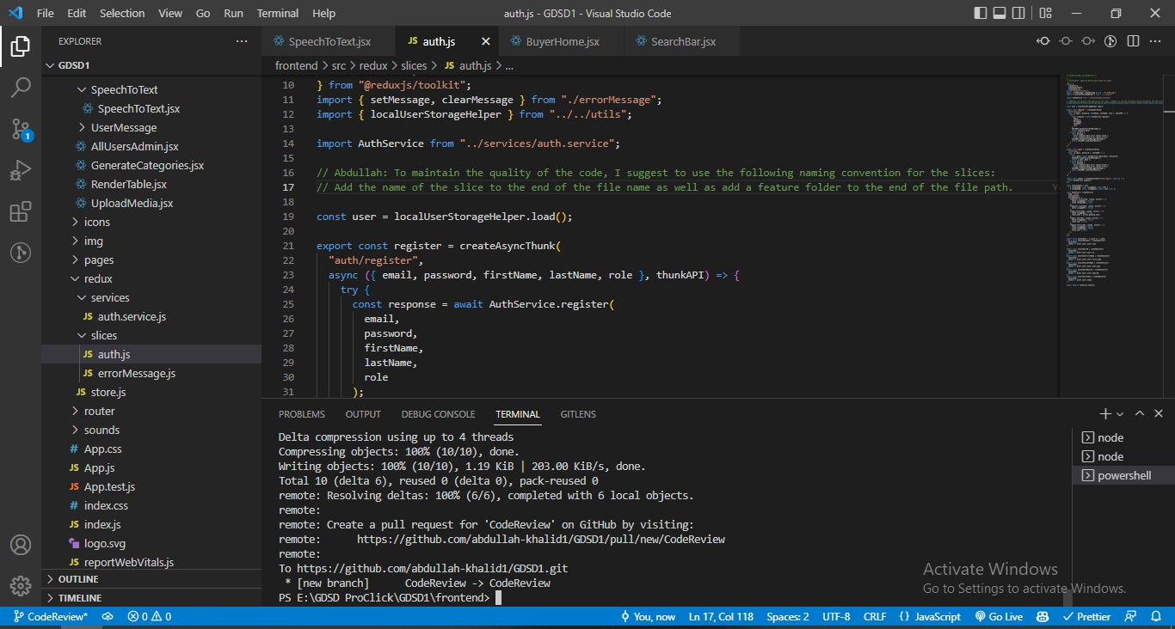

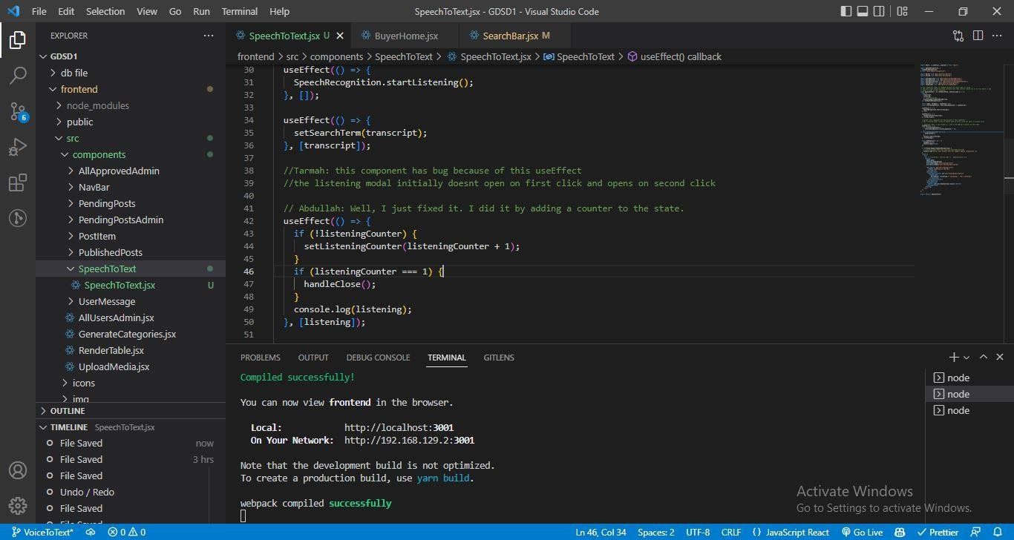

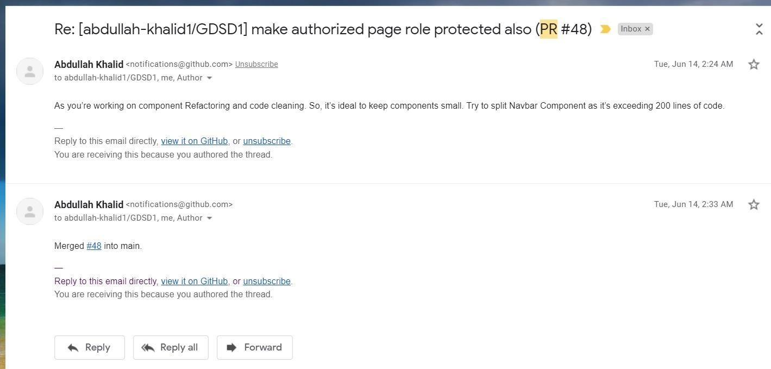

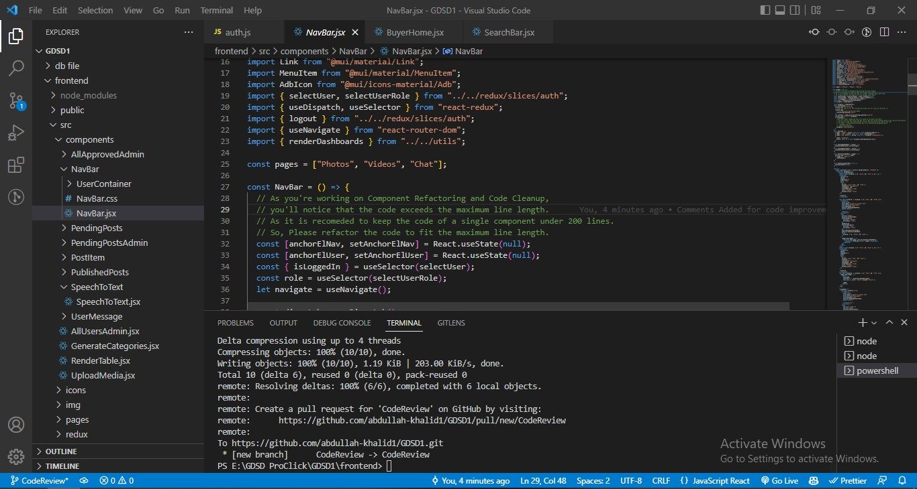

* Code review by Bilal
* Done by Mayank Chetan Parvatia

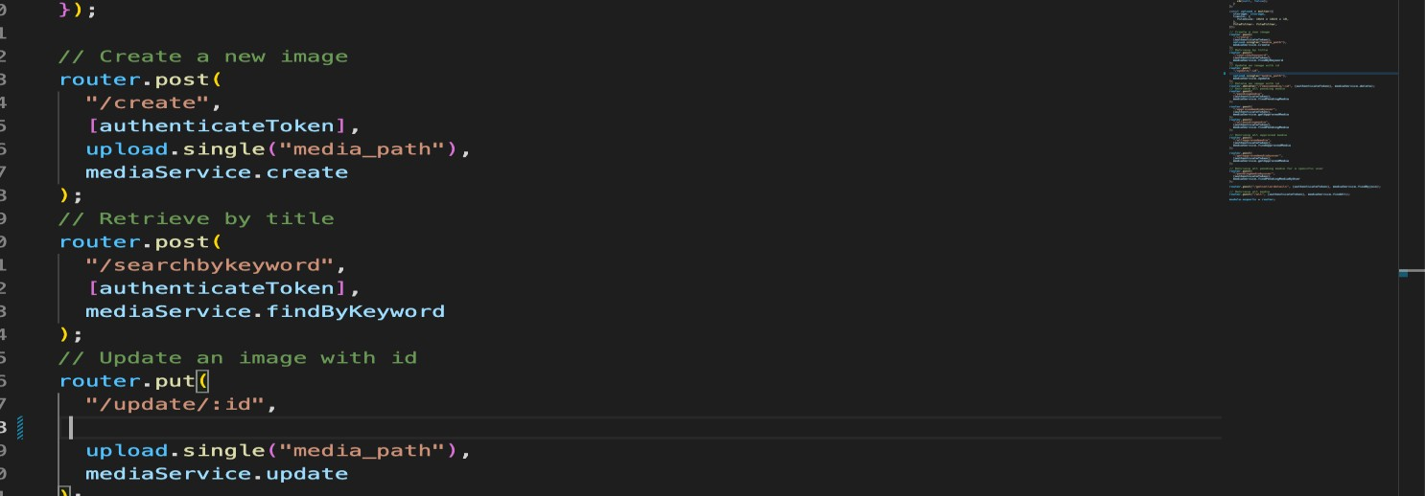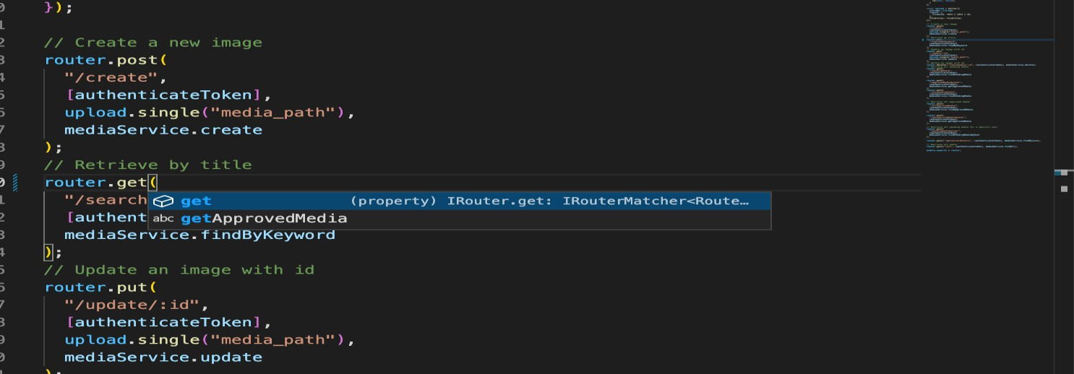

Add Authentication TOKEN to update. You missed token while making Api.

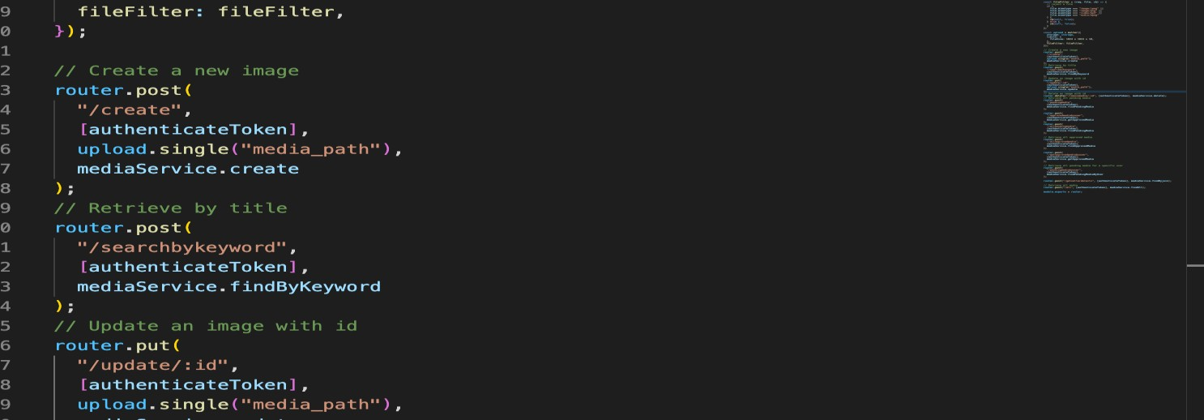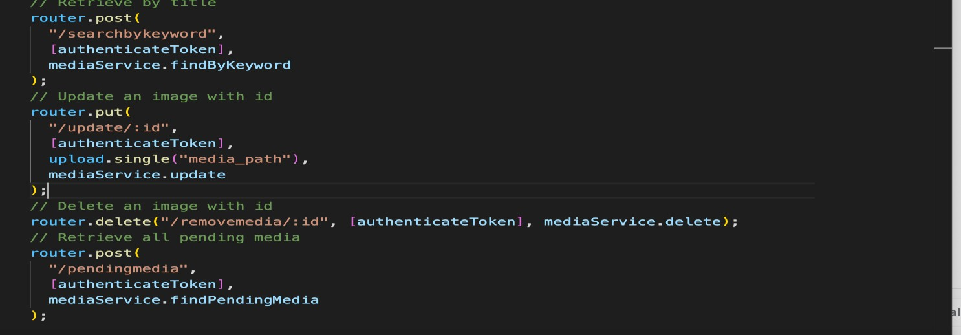

Use the post method instead of get method because you are posting data to search for something.

* Code review by Mayank Chetan Parvatia
* Done by Bilal Ahmad

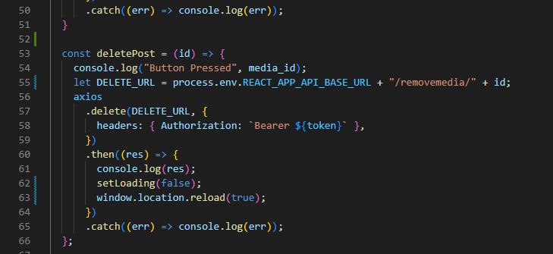

The path was not correct, it should be “/media/removemedia”. The media class was missing.

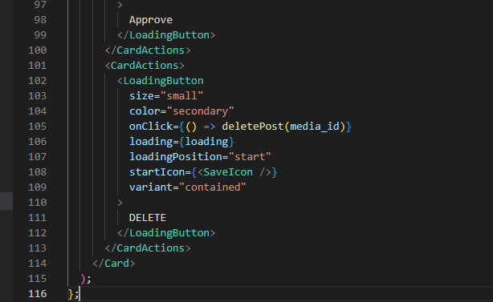

On clicking this button it redirects to the home page. The error message is also not shown.

* 1. Self-check on best practices for security
* List major assets you are protecting
  + Passwords
  + Admin routes
  + Private routes
* List major threats for each asset above
  + Passwords: should be encrypted, otherwise if the database is hacked and the passwords are stored as a plain text, then all the accounts will be exposed.
  + Admin routes: admin functionalities are critical and only authorized users who have admin privilege can access these routes, otherwise, any user can manipulate the posts and site users improperly.
  + Private routes: only authenticated users should access these routes like the chatting and adding posts routes
* For each asset say how you are protecting.
  + Passwords: using encryption, so all passwords are hashed and saved in the database.
  + User routes: verifying the token sent in the request header and checking the user role before allowing him to access the API using the "userMiddleware.js" middleware
  + On the client side the admin and private routes are not accessed by not logged in users
* Confirm that you encrypt PW in the DB: We are saving the passwords hashed and not as plain text in the database using the Bcyrptjs hash which is one way hashing and cannot be converted to the plain text password. Besides incorporating a salt to protect against rainbow table attacks, bcrypt is an adaptive function: over time, the iteration count can be increased to make it slower, so it remains resistant to brute-force search attacks even with increasing computation power.
* Confirm Input data validation
  + Valid Email address: a checking function is used in the signup to verify that the email address has a valid format and is related to Fulda
  + Strong Rules for passwords: a checking function is used in the signup to enforce the user to choose a strong password that complies with the rules of the website (8 min length, one small, one capital one digit and one special char)
  + Limit the search field for up to 40 characters max: limiting the size of the input field to 40 characters max, and preventing the user to exceed this number

4.8 Self-check: Adherence to original Non-functional specs

|  |  |  |  |
| --- | --- | --- | --- |
| **List of non-functional requirements** | **DONE** | **ON TRACK** | **ISSUE** |
| **Application shall be developed, tested, and deployed using tools and servers approved by Class CTO and as agreed in M0 (some may be provided in the class, some may be chosen by the student team, but all tools and servers must be approved by class CTO).** | **🗸** |  |  |
| **Application shall be optimized for standard desktop/laptop browsers e.g., must render correctly on the two latest versions of two major browsers** | **🗸** |  |  |
| **All or selected application functions must render well on mobile devices** | **🗸** |  |  |
| **Data shall be stored in the database on the team’s deployment server.** | **🗸** |  |  |
| **No more than 50 concurrent users shall be accessing the application at any time** |  | **🗸** |  |
| **Privacy of users shall be protected, and all privacy policies will be appropriately communicated to the users.** | **🗸** |  |  |
| **The language used shall be English (no localization needed)** | **🗸** |  |  |
| **Application shall be very easy to use and intuitive** | **🗸** |  |  |
| **Application should follow established architecture patterns** | **🗸** |  |  |

|  |  |  |  |
| --- | --- | --- | --- |
| **Application code and its repository shall be easy to inspect and maintain** | **🗸** |  |  |
| **No e-mail clients shall be allowed. Interested users can only message to sellers via in-site messaging.** | **🗸** |  |  |
| **Site security: basic best practices shall be applied (as covered in the class) for main data items** | **🗸** |  |  |
| **Media formats shall be standard as used in the market today** | **🗸** |  |  |
| **Modern SE processes and practices shall be used as specified in the class, including collaborative and continuous SW development** | **🗸** |  |  |
| **The application UI (WWW and mobile) shall prominently display the following exact text on all pages *"Fulda University Software Engineering Spring 2022. For Demonstration Only”* at the top of the WWW page. (Important to not confuse this with a real application).** | **🗸** |  |  |